SSWAG

SCHOOL SOCIAL WORKERS ASSOCIATION OF GEORGIA

Historical Moments

- January 16, 2024- The E-Board sanctioned video showcasing the diverse and unique work of SSWs was presented at this E-Board meeting. The video was produced by Lansing Productions
- 2024- SSWAG Committee launched a new evaluation tool tailored to the unique work of the SSW. President Brown-Pinkney invited SSWs to participate in a pilot program for its use. The counties included are Bulloch, Clarke, Dalton, Effingham, Glynn, Gwinnett, Henry, and Rockdale
- 2023- Virtual Fall Conference was November 10th and the theme was Leadership Through the Social Work Lens
- Nov 30, 2023- Announcement: SSWAG member, Sandra Wilcher, was appointed Superintendent of Schools for Lowndes County Schools. She is believed to be the 1st SSW appointed to such a position in Georgia's history. Sandra was a dedicated member of SSWAG for many years, having been very active in her district, served as our SSWOTY, and made valuable contributions to the organization while serving on the Executive Board https://www.facebook.com/100064781406737/posts/pfbid06E6uEEN8Gz9Cp2NgFswRkkk8zrzEsu6jSSP8Z5mXzS1EwvSADJNP1H4YCH2bUz7Jl/?mibextid=I6gGtw
- Sept. 2023- Kennesaw State University invited 6 SSWs (2 rural, 2 urban, 2 suburban) to assist/advise with the development of a SSW course that prepares KSU students in innovative ways. Additionally, they are seeking someone from the SSWAG membership to teach the course
- May 2, 2023- Announcement: Dr. Denise Scott, a former SSW was appointed Assistant Superintendent of Student Services in the Bryan County School District
- Sept 2023- PAGE Legislative Survey seeking SSWs input that serves to shape PAGE Advocacy
- 2022-2024- SSWAG President- Dr. Jackie Brown-Pinkney, Effingham County SSW
- January 2023- The SSW Lead Program was launched to empower and support SSWs in their journey towards becoming influential leaders in the field. It is open to Georgia SSWs
- 2022- 2023- The 1st SSWAG You Make a Difference Scholarship recipient is Ottoria Foreman
- 2022- SSWAG returned to in-person spring conferences after the Covid pandemic. This conference was held in Jekyll Island, GA and it was a collaboration with the Professional Association of Georgia Educators (PAGE). This collaboration marked a significant reconnection between the two organizations, as PAGE had not been actively involved with SSWAG for quite some time
- 2022- Board achievements included: a facelift of the SSWAG website; update of the Procedural Guidelines and Strategic Plan; Press conference at the State Capitol; the SSWAG You Make a Difference Scholarship was chartered; membership reached 315; and GA SSW Dr. Terriyln Rivers-Cannon was elected SSWAA President
- 2021- GaDOE hires SSW Specialist, Dr. Lindsey Oliver and SSW moves to the Office of Whole Child Supports
- 2021- The Impact of Trauma on Students in Foster Care (HB 855) passes
- 2021- New website host https://www.sswaga.org/
- 2020- With the onset of the COVID-19 pandemic, GA SSWs had to pivot and reimagine SSW in the virtual world. Conferences went virtual
- 2019- National SSWOTY awarded to Atlanta Public Schools SSW Dr. Terriyln Rivers-Cannon
- 2018- Governor Nathan Deal appoints SSW Dr. Jackie Brown-Pinkney to the GA Composite Board of Professional Counselors, Social Workers and Marriage and Family Therapists
- 2017- SSWAG logo change under the Presidency of Dr. Terriyln Rivers- Cannon
- 2015- SSWAG Mentor Program chartered under the Presidency of Dr. Chiquetta Thompson and Dr. Jackie Brown-Pinkney was appointed chair
- 2014- 2015- For the spring conference, Dr. Renee Glass-Dixon collaborated with GADOE to fund the first collaborative SSWAG and School Counselors conference
- 2006- 250 SSWAG members
- 2005- SSWAG redistricting: The combined 3 & 6 District opted to separate and District 8 divided into two separate districts
- Updated the practice manual issued to members
- 2005- SSWAG redistricting: The combined 4 & 5 District opted to separate. The action resulted in two different SSWAG Districts
- 2000- Governor Roy Barnes lowered the SSW to student ratio from 1 : 3300 to 1 : 2475 as part of HB 1187. Gov. Barnes also signed the SSW week proclamation. SSWAG created its first organizational website. President William Clinton renamed Stewart B. McKinney Homeless Assistance Act to McKinney-Vento Homeless Education Act to honor both major supporters of the act
- 1999- SB101 proposed by Senator Madden to increase the number of SSWs for remedial education- it was passed by the Senate and House, but removed from the budget
- 1998- Sandro Blalock (Tift Co. SSW) was appointed by Gov. Zell Miller to be a member of the Children’s Trust Fund commission. Membership pins distributed for the first time. GAE proposed to lower the SSW to student ratio in their legislative agenda
- 1995- SSWAG adopts a new organization symbol. The new SSWAG logo was voted on by the membership. SSWAG Executive Board votes to hire an Executive Secretary. American actor, producer and social activist Danny Glover defended SSWs in a rebuke to a speech made by a representative of GA’s Department of Education
- 1994- SSWAG, Inc. receives tax exempt status. Don Lyons receives the Elsie Nesbit Friendship Award. 1994-Georgia SSW delegates sent to Illinois to discuss formation of School Social Workers Association of America (SSWAA)
- 1993- SSWAG is officially incorporated and becomes SSWAG, Inc. thanks to the volunteer efforts of Judge Johnny Warren of Dublin, GA
- 1992- School Social Workers had a major regulatory victory when the Federal Register published the Department of Education’s revised regulations to Part B of the Individuals with Disabilities Education Act (IDEA) and NASW was successful in persuading the DOE to withdraw the proposed deletion and maintain the title, social work services in schools
- 1991- There were 222 certified SSW and 142 Attendance workers employed by the state of Georgia. Gov. Zell Miller signs the 1st GA proclamation recognizing March 18 - 22 as School Social Work week
- 1990- HB677 gains approval from the GA House and Senate with support from Dewayne Hamilton
- 1989 (spring)- Dr. Gail Kurtz provides leadership training to the SSWAG Executive Board and a mission statement is born. “The School Social Workers Association of Georgia exists to improve the quality of services to the students so as to enhance their individual and educational potential.” (fall)-18 representatives from 6 states (GA, KY, NC, SC, TN, VA) met at the Knoxville airport Ramada Inn in Alcoa, TN to form the “Southern School Social Work Council.” The purpose of this new organization was “to promote professional excellence among those who practice School Social Work in order to enhance the quality and delivery of School Social Work services in educational systems''
- 1988 (spring/fall)- SSWAG voted to increase membership dues from $20 to
$30; there were 131 SSWAG members. The Georgia Department of Education projects included: creation of a video tape on School Social Workers in Georgia; the development of a SSW referral/reporting form; and finalization of a SSW job description. SSWAG voted to employ a lobbyist. There was a presentation of the School Social Worker Evaluation Instrument (SSWEI) by Robert Newton at the SSWAG Spring Conference
- 1987- Membership count of 156 and President Ronald Reagan signed the Stewart B. McKinney Homeless Assistance Act into law to address the growing homeless population of women and children
- 1986- SSWAG voted to increase membership dues from $15 to $20. Position statements were written on homeschool, dropouts, and teen pregnancy. There were 187 paid SSWAG members
- 1985- A Memorandum of Agreement was signed between Georgia Association of Educators and SSWAG
- 1984 (summer)- Implementation of School Social Worker of the Year Award
- 1983- SSWAG President Randall Smith signs a resolution requesting that Georgia legislators revise the 1945 Compulsory School Attendance Law to make it congruent with existing laws and educational needs of the state
- 1978- The Georgia Visiting Teacher Association renames itself the School Social Workers Association of Georgia (SSWAG). This change reflected a new emphasis on Social Work in the school setting
- 1971- The African-American and Caucasian VT/SSW associations merged into the Georgia Visiting Teacher Association. This was prompted by the merger of their affiliates, the Georgia Educators Association and Georgia Teacher and Educator Association, into the Georgia Association of Education (GAE)
- 1964- African-American and Caucasian VTs/SSWs began to interact when UGA permitted both races to join forces for training and certification
- 1956- Mary Calhoun, an Albany VT, was chosen Dougherty County’s “Woman of the Year”
- 1955- There were a total of 144 paid members in the GAVT. The Visiting Teacher…. In GA, the first publication to specifically assist VTs in GA was published by the State Board of Education Co-Authored by Elsie Nesbit, Visiting Teacher Lee County Schools, Leesburg, GA, and Florrie B. Still, Coordinator GA Visiting Teacher Service State Department of Education Atlanta, GA
- 1954 (fall)- Florrie Still, Hall County VT, was appointed to the staff of the GaDOE as Coordinator of Visiting Teacher Services
- 1953- local systems were given the freedom to choose for the first time whether or not to continue the VT program. The program was continued with 150 county school systems and 25 independent school systems
- 1950- Paul West, Superintendent of Fulton County Schools stated that, “the VT is, in reality, an indispensable liaison between the school and the community and is in a unique position to help both. As such, she is one of the most important people on the school staff.” In August, a committee comprised of Dorothy Lester, Katherine Walker, and Elsie Nesbit met with Dr. Collins (GaDOE Superintendent) to express the need for a state DOE consultant for the Visiting Teacher Program
- 1949- Dr. Collins, State Superintendent in speaking to the Economic Committee, of the tax revision committee, on behalf of GaDOE stated “we believe it is good judgment to spend a few thousand dollars in prevention rather than missions in penal custody, rehabilitation and public assistance” in response to the value of VTs
- 1948- The second annual conference of Visiting Teachers was held in Atlanta with 125 (VTs) in attendance. The Georgia Department of Education (GaDOE) compiled the VT’s data from across the state and found that 5399 referrals were made monthly as well as 1303 students enrolling in school for the first time
- 1947- The first Statewide Visiting Teacher conference was held in Atlanta. The Georgia Association of Visiting Teachers (GAVT) was formed, but membership was limited to Caucasians. GAVT was organized as an affiliate of the Georgia Education Association (now known as the Georgia Association of Educators). The same year the Visiting Teachers Association of Georgia, an affiliate of the Georgia Teacher and Educators Association was organized for African-American Visiting Teachers
- 1946 (fall)- 40 Visiting Teachers (VTs) assembled at the University of Georgia and organized themselves into districts
- 1937- A State Board of Education, to be composed of laypersons rather than professional educators, was established to oversee and coordinate the delivery of education
- 1916- Georgia’s first major statewide education initiative where the General Assembly enacted legislation making school attendance compulsory for all children between the ages of eight and fourteen

References
Grant, Chris. "Education Reform." New Georgia Encyclopedia, last modified Jul 30, 2018. https://www.georgiaencyclopedia.org/articles/education/education-reform/
Georgia. Department of Education (1955). The visiting teacher ... in Georgia : works with the child, school personnel, parents, and community, to help the child. Retrieved from http://dlg.galileo.usg.edu/do:dlg_ggpd_s-ga-be300-b-pm1-b1955-bt4

Appendix A
The Visiting Teacher…in Georgia
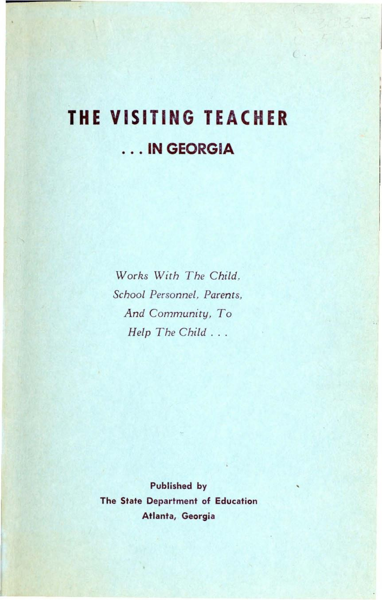

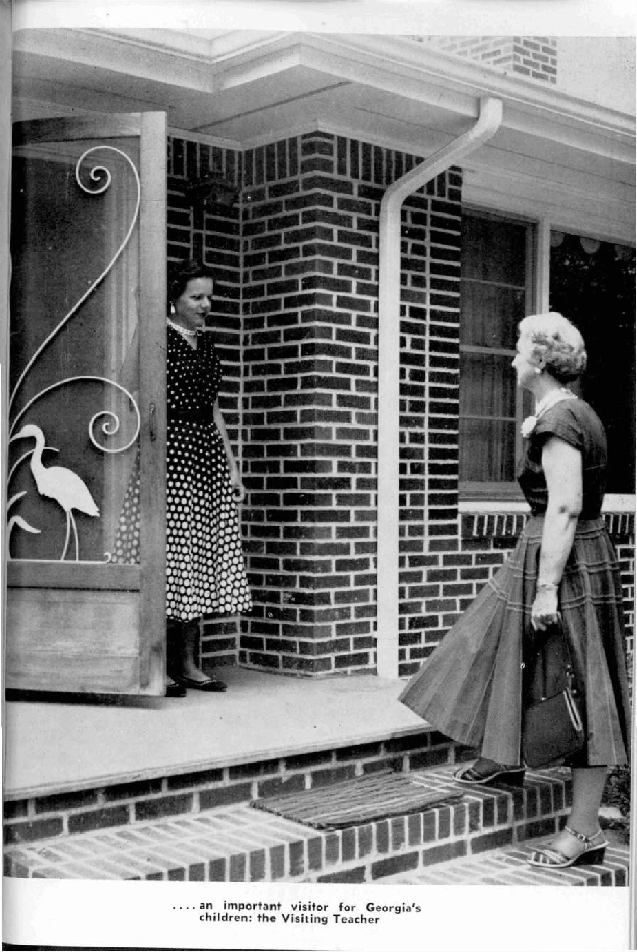

THE VISITING TEACHER
. . IN GEORGIA

Published by
State Department of Education of Georgia

Atlanta, Georgia
May, 1955

Co-Authors

Elsie Nesbit, Visiting Teacher
Lee County Schools, Leesburg, Georgia and
Florrie B. Still, Coordinator Georgia Visiting ’1 eacher Service State Department of Education Atlanta, Georgia

TABLE OF CONT ENTS

Page

CHAPTER I. WHAT IS TNE VI SITING TEACH ER PROGRAM*. 9
HDw Is The PrOgr@m Organized? .................... ..................., .. , ,. \ 0
A Place to Call Her Own .. . ....... 10
A Plan to Use Her Time .. .. . ................................... „ ,. , \ 0
A Bird's Eye View \ 1
The School and Attendance .... ........................ . . , ,.., .... ........, \ \
CHAPTER I l. WHICH CHILDREN NE ED HE R f•lELP‘? \ 3
Metheds of Mak ing RefeFra Is .................. ............ „ 13
Who Are These C hil dren? ... ............. , ,. , .... ...... ,., „, .. , ,. , \ 3
£0 U@ I BS /1/@£e W 6V9 . . . ............. , , . , ........... , . , , . , , .. , \ @
These Things the Visiting Teac her Does Nof Do ......... IN When Does She Refer to Community A gene ies? ..., ,. ,.........., ., , ., ,. , \ 6
CHAPTER III. THE VISITING TEAC HER AND NER COLLEAGUES \ 8
What's the Visiting Teacher Like as a Person? .„„„„ 19
How She WorLs wiFh System Superintendenf and Board of
Educat ion.. ..., , „, ,., .., .........................., . 20 ”
How She Works with the Pr inc ipal ... ...., . .. . .. . ... ... . . .. ,.. ., , „ .. ,..,.., ,.,.., „, ,., , ,20
I•{ow She Works with the Classroom Teacher 22
Conferences 22
Sharing 21
Dec iding en Referra Is 24
Ie ii\ay G6t \fI/Ot'SE 2/
How She W0'Fks with Oth er School Personnel , „, „, , ,.,. 25
CI•IAPTER IV. LET‘S GET DOWN TO CASES 26
What Is Casework? 26
Ways of Wo rLing with Ch il dren 26
The InI erv i ew 26
The Relationship
j0tC€ep}8 f3Ce //
Other Techniques ............ .. ................... ......., ..., ,., .., „, „ 27

How ] s the Visiting Teacher Tra ined? |  | . ........... | 28
CHAPTER V. THE CHILD HI/y\5 ELF  Face to Face . .. ... .. .. | „  . | .. . .. .. - - - | 30  ..... --.3I
Getting the C h ild in Focus |  |  | 31
Standing On His Own Feet ...................... |  | .. . .. ................ .. .. | .. ..31
Choices .... .......... ................................,. 32
Testing the Relationsh ip 33
The Chil d's Own Strength 33
Grawin Up Is a Big Job 35
The Heart of the Serv ice . . . .. ....... . .... . . ........., ... ,.,. 35

TABLE OF CONTENTS
Page
C FIAPTGR VI. TI•IE CI•II LD’5 FAMILY 36
When and Why the Family 1s Important 36
How the Family HeIps .,. 38
The School‘s Par'f in Helping the Child 39
CHAPTER VI I. PREVENTIVE ASPECTS OF THE PROGRAN\ . . ... 40
Ea rly Symptoms 40
Strafed ie PosiI ion of Teachers 40
OW TO K n OWN . , . , , . , , . , , . , , , , . , ....... , @g
l•la Is Not “Bad“ 42
A d0 B 5€ BN €B , .......... , .. , .. , . , , .. , .... , , . , , @4
Self-Referra Is .. . . . . .. .... ...... . ..... ....... . . . . . . ., , , , . , „ 45
The Child Knows It 45
The Matter of Juvenile Delinquency . . . . . . ............. , „„,. 45
Before It Is Too Late 46
Ch ildren Al ready \ n Trouble . , , 46
CHAPTE R VI I I. THE CONSTRUCTIVE USE OF AUTHORITY 47
Feelings About Authority ......................................... . . . . . . .., ,. 47
I nheren£ Autherity ., ,.. .. .. ., ,. ,.., , 48
Staying With Yhe Child 49
He Does Decide 49
Delegated Authority 50
Constructive and Not Destructive .............................. . .„.,51
In Cloae Toueh ST
Indications for Referral 52
CHAPTER IX. WHAT OF THE FUTURE? S3

“

The Visiting Teacher and Georgia's Children
The child—whoever he is, wherever he is is the focus of all our efforts in the Georgia school program.
The Visiting Teacher has done a remarkable job in helping the Georgia child. Our Legislature in 1945 wisely passed the new Compulsory Attendance Law. The Visiting Teacher program was started to make this law effective. Her job was not just to check absentees, but to find the cause, and help solve the problem back of it all.

Everybody in the school program in Georgia has the same
purpose: to help the child be his best and do his best.
No group makes a finer contribution toward this than our Visiting Teachers.
They work with the child, his family, and his community to relieve the pressures, lessen the emotional tensions, and suggest solutions for specific stresses that might handicap him. Their way is to help the child help himself. They reach out to steady him, to strengthen him, and to help him find self-reliance.
Their work is not well known to the public. This is largely because it has to be confidential if it is to be of real value. These wise and well-trained people work quietly. Their competence and cohcern reassures the child and his family; their efforts strengthen the school program and give it more value to the community.
Their work has been recognized as one of the effective helps in preventing juvenile delinquency. It has strengthened the hold- ing power of the schools. It has changed many a frustrated child and parent into happier, better adjusted persons. The service promotes mental health. It has promoted better family relation- ships and more efficient classroom work.
We have sound reasons to be genuinely proud of the achieve- ments of Georgia‘s Visiting Teachers. We need more of them. IN there is one in your community, you can help by giving her your warmhearted, appreciative support. If there is not one, consider with your neighbors and school leader the good you could do your community’s children by providing them Cth the under- standing counsel of a visiting teacher.
I hope you will read this bulletin. I am confident that in its pages you will find a better understanding of what the Visiting Teacher Service means to the school program in Georgia.
M. D. Collins, State Superintendent of Schools

A Better Understanding of This Service
Why This Bulletin Was Written
5tate-wide visiting teacher service was established in Georgia in 1945. Since then much work has been done in local, district, and state groups to clarify the function of the service as an in- tegral part or the total school program. However, very little has been written, and most interpretation has been given by word of month. So, like any other such communication, it has been under- stood differently by different people. One would assume, then, that the local meaning of the service has been largely dependent upon its interpretation and use in the local school system.
The State Board or Education in the beginning set forth over- all policies to regulate and give direction to the development of this program. These policies in general have remained unchanged. It is now deemed good that a more specific description of the service be made available on a state-wide basis to all who are concerned with the use of this service. Such a description can be of value to school administrators as they plan for a more effective visiting teacher program in their system. It can enable parents to become better acquainted with one of the services the school ofiers. Classroom teachers will find it helpful in planning the best use of a school resource for the benefit of the children in their care. This material should enable community agencies and other non-school personnel to understand better the purpose and plan for work in which the visiting teacher operates within the school. A better understanding of the service may inspire suitable young people to enter a program which renders a specific service of far-
reaching implications to individual children.
The philosophy of the service as given in this material is not limited to Georgia, but is found in any good visiting teacher pro- gram. In all states which have such a program leaders are working toward the common goal of providing a better and more uniform service. In this bulletin we have tried to bring together the general philosophy, purpose and plan agreed upon not only in Georgia, but throughout the nation.

I wish to thank Miss Nesbit for her fine contribution to our
state program through the time and effort given to this pubkca-
tion. Her work makes this publication possible.
The pictures were made by the Audio-Visual Service of the State Department of Education. Helpful teachers and Department staff memebers posed for them. For this co-operation we are ap- preciative.

Florrie B. Still, Coordinator Georgia Visiting Teacher Service

CHAPTER I
”Our and our,
qoecfions”

what IS The Visiting Teacher Program?
Over and over the questions are asked: What is a visiting teacher? What does she do? This description is an attempt to answer these questions by looking first at the service as a whole and then at some of its specific features. One theme is predomi- nant—the service is not an appendage to but an integral part of the school.
The visiting teacher works on an individual basis with child- ren, their teachers, and their parents. The focus of the work is always on the child. The work is with children who find it difficult to come to school or to participate in a satisfactory way when they do come.
The service does not cover all school problems, nor all prob- lemof children. Scores of problems are handled daily in the classroom with no need for other help, and community resources are used to help with problems for which the school is not re- sponsible. The service does not duplicate or relieve other school personnel of their own duties. It is not for discipline nor for academic teaching but for helping children solve their problems.
Compulsory school attendance laws make the school respon- sible for teaching all children who are educable. This challenges the school to fit the curriculum to the needs of all children rather than to attempt to fit the children to the curriculum or to allow them to drop out as misfits. Yet, there are many children who are unable, for various reasons, to take advantage of what is offered them even in the most adequate curriculum. These are the chil- dren with whom the visiting teacher works. She offers one of the services which assist classroom teachers in their duties of teaching all children.
Along with all other school personnel, the visiting teacher represents the positive and constructive aspects of the school to the child. 'I'hey believe in the rightness of school for children and in helping to make the school a happy place for them. In spite of cartoonists who still liken the opening of school to a cactus bed into which the child falls helplessly, school people believe that the child who is happy, who can manage his own problems with minimum adult assistance, will And satisfaction in school. The visiting teacher is one of the people who can help the child learn how to manage himself if he finds it difficult to do so alone or with the help which his teacher and his parents give him.

(8)

’Oryani zation rriahes
the dii!erence”

How is The Program Organized?

The many facets of the visiting teacher program can be com-

pared to a jigsaw puzzle. Unassembled, the little relation to each other; assembled, each Organization makes the difference.
pieces seem to bear
fits into the pattern.

In the process of planning, duties are defined which serve as guideposts not only for the visiting teacher but also for others who use the service.
A Place to Call Her Own. The visiting teacher works in the entire school system or in certain assigned schools but should have a “home base” where she can be contacted or where mess- ages can be left. It should be sufficiently private to allow for conferences and undisturbed work. Many records are of a con fidential nature and should be kept locked.
In addition to a central office, interviewing space should be available in each schOOl. A place to work in the school gives status to the visiting teacher and enables teachers and children to know where to find her. In crowded buildings this may be quite diffi- cult, but the principal and visiting teacher should plan together to do the best they can. The corner of a hall, a book room, or a cleared-out storage space have been used when there was nothing better. In platlning new buildings this need should be considered.
Circumstances in each local system will determine the amount of clerical help which can be provided. The more the visiting teacher can be relieved of routine duties, the more time she can have to work with children. Assistance in compiling statistical reports and typing records are two services which would help to make the program more effective. A dictaphone or other kind of recorder saves time and provides more adequate records if such equipment is available.
A Plan to Use Her Time. Though emergencies do arise, an orderly way of working is important. A schedule helps direct the visiting teacher's thinking and avoids the temptation to be guided by her inclinations day by day. To be sure, the varied nature of her work requires a schedule that is flexible. The same is true of the teacher. Because there is a class scheaule, the teacher does not abruptly call a halt to all other activity at exactly nine fifty- two every day in order to begin arithmetic. The schedule in high school is of necessity less flexible than in elementary school but not as rigid as it might appear on first thought. It provides the time limits essential when a number of people must work to-
(10)

gether. The visiting teacher works with a number of different people daily, and a schedule provides a constructive use of limits for herself.
Planning her time enables the visiting teacher to do more and better work. If schools know when to expect her, referrals can be ready. A schedule is necessary in planning regular con- tacts with children and in making appointments for home or office visits.
A Bird's Eye View. In additioii to her major duty of working i with the children who are referred, there are other ways in which the visiting teacher functions as a part of the staff of the school.
She may participate in faculty study groups. As one of the people who know the total school system, she is in a position to be of help in system-wide planning. She is definitely a part of the local teachers' organization and should take an active part. As a link between school, community, and home, she can be a valuable aid in promoting understanding in all these directions.

The School and Attendance
Attendance problems are of major concern for the whole school. Truancy and non-attendance are no longer considered crimes but are known to be symptoms of trouble. Therefore, these problems are treated as other school problems are treated by discovering the cause and helping th.e child find a more satis- factory way of handling it.
Attendance is the responsibility of the entire school and com- munity. An attractive and meaningful school program, under- standing teachers, positive attitudes on the part of parents and community in general toward school and school attendance, and economic security can do more to promote good attendance than mere enforcement of the law. These preventive measures are more effective than relying on the law; yet there is definite need for the law. Delegating responsibility to specific persons for carry- ing out the purpose of the law is needed to complete a well- rounded attendance program.
Attendance is a prerequisite to education. The child cannot be taught if he is not there, but his physical presence does not insure successful learning. He can be mentally as well as physi- cally truant. When difficulties become too great, the easiest solu- tion sometimes is to leave. When parents do not understand or care, they need help in becoming more understanding. Handling these situations requires the same kind of skills the visiting teacher uses in handling any other school-connected problems of children.

(11)

Along with the importance of r ttendaiicc is the importance of knowing all the children who should be in school. It is the re- sponsibility of the entire school to keep the school census up to date, with the visiting teacher assisting in planning and coordi- nation. Attendance measures are not as cffec tive as they should be unless there are workable means of accounting for all children who should attend.
Treating truancy and non-attendance as s›unpioms of diffi- culty and considering attendance tL e responsibility of the whole community is a positive apprOach, iVhiJe punishment is negative. School is a good place for children to be, and they will learn more happily and successf ully when this is the prevailing com- munity attitude. Yet, most schools and coin munitics fall some- what below this ideal. Not all chi ldmn find school a good place to be nor do all communities cooperate so ivell. I hildrcn must learn to live with authority instead of in conflict with it. When parents do not themselves give to their children their right to an education, the State must do it for them. \ isiting teachers or at- tendance officers are obligated by law to car ry out this purpose. Their responsibility in enforcing the law will be discussed in a later chapter.
School attendance is a part of the accepted standards of society and those who ignore or defy this standard are paying a high price for their non-conformity. This suggests that the un- derlying causes must be of such intensity that the disapproval of society is risked. Having to be in schiiol when everything seems to go wrong for him may make the child reel trapped and unable to escape. ’l’L•ere may be fear of I ailure; but running away is not failure; it is escape. Hence, he may become truant. The child from an insecure home may feel that he is being re jected when he has to go to school while his younger brothers and sisters can stay at home. ’l'he demands of school may be too great for some chil- dren. There may be worry over events at home. Forgetting the child‘s rights, a mother might retTcat into illness to keep her child at home. A father may feel that it is th* duty of his children to work for him. r*l’hese are examples tif the need for careful study of the causes behind poor attcr dance. '1'ruaney and ‹trop-outs, as well as other school problems, may be prevented by detecting earlier and less serious symptoms of difficulty or maladjustment in school.

(12)

CHAPTER II

Which Children NEEIg Her Help?
What is meant by a referral? It is simply the means by which the visiting teacher is notiiied of the children who need her help. She does not begin working with children on her own initiative without the knowledge of the teacher and principal. The referral implies a request for a definite service. lf the visiting teacher knows of a child who seems to be having difheulty in school, she should discuss the matter z ith the proper person at school. To- gether they decide how the problem should be handled. The re- ferral process is a vital part of the visiting teacher service. There is no ritual about it. The most convenient way of getting the child to the visiting teacher is usually the most satisfactory.
Methods of Making Referrals. What is the procedure for referral? Parents sometimes write a note or come to the school. Community agencies call the visiting teacher for a conference. Principals and teachers talk to the visiting teacher about a child or a family. Someone stops her on the street or in the grocery store to make a referral or to ask for information. All of these are natural means of communication. The fact of referral is more important than the method, but planning can make it more ef- fective. Within the school, written referrals are more satisfactory. 3’hey do not take the place of conferences, but stating the problem in writing brings into focus the specific problem on which work should begin. Having written referrals placed on the principal's desk is a simple means of keeping him informed as to the children who are referred.
Plans can be worked out for mutual referrals with com- munity agencies. From whatever source the referral comes, th* visiting teacher should talk with the appropriate person at school before any plans are made to see the child.
Who Are These Children?
Visiting teachers are not the only ones who help children with their school problems. Teachers and all other school per- sonnel are doing it constantly. Some problems are resolved more satisfactorily in the group than individually. Others need indi vidual help in addition to and different from that which the teacher gives. Those who are showing symptoms of social, erno-
(13)

tional, or scholastic waladiustment come within the scope. of tbe visiting teacher's responsibility to help. Deviation from normal bebalor or perfoz aaee te tbe zaost usua1 syzoptoza.
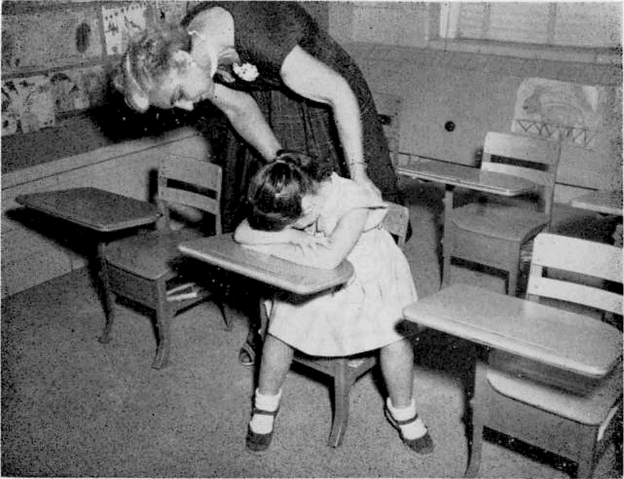
. . . . 6er the eh\ld In a big, baMlng werld, c reassuring. friend

The service should be availabte to all children when they need it just as health or other services should b:e arnlable to all. Estimates of the possiöle number who may need such service ,
from two per ceat to ten per cent or znote of tbe scboo1 p•puIa-
tion. The number who can actually zeceive sucb belp dspéods on
the number of schools and the enrollment served by one vistting teactier. 7be type of service, bowexer, sbould not vary fzoot )arge to small Systems. lt is better to limit the number served than to gtve a supe‹dciaI aer tce to ‹aany.
Troubies £hlldren Have. Wbat \dnds ob bebavioz are sigos
of ditficulty? It is not the ordinary mischief or temporary ill-
eause concern, but the chroaic,. unusual, Or "Ü t-

ferent" aeüoin on the
bimself or for bla group.
ot the ehild which cause trouble

'I'be timid, witbarawn ehild who sits

ignoring the group and ignored by It, may have a more serious
(14)

problem than the overly aggressive person u hose behavior will not be tolerated by the group. The aggressive boy or girl is at least doing something to relieve the tensions, while the timid one may be retaining tensions within himself. Both need help to find acceptable ways of handling their problems.
Children who steal, lie, tell fantastic tales, quarrel constantly, daydream excessively, show off, carry a chip on the shoulder, sul'‹, have temper tantrums, pick on others, or are always at odds with the group are saying clearly that something is wrong and they need help. Laziness, indifference, shirking of responsibility, lack of cooperation, lack of dependability, impudence, and many other non-conforming attitudes are symptoms rather than dis- eases. They are the child's way of saying that everything is not right for him. He may not think there is anything wrong with h'm but that the trouble is outside of himself in the school, at home, bad luck, or just the way the world is anyway. On the other hand, he may think that it is all because he himself is bad. In either case, he does know something is wrong whether he ad- mits it or not. These are some of the children with whom the visiting teacher may help.
Others who need the service are those who are failing in school work or making poor grades though they have the ability to do the work. All schools know of students of superior ability whose achievement is very poor. Something is interfering with the use of this ability. At the other end of the scale are children who become confused and discouraged because of the pressures of school to achieve more than they are able to do. And, in be- tween the two extremes are many children who do not make the best use of their capacity for learning. The visiting teacher may help them make better use of their abilities.
There are various other reasons for referral to the visiting teacher. Many problems of children begin in the home but are reflected in the school. Parental neglect, indifference or hostility to school, economic strain or discord in the home affect the child's ability to use the school successfully. Truancy is a sign of a problem of long standing. It is running away, taking the easy way out of an intolerable situation. Not the truancy alone but what makes school intolerable is the concern of the visiting teacher. Delinquent behavior comes in the same category. Children who have lost faith in themselves or in adults need help desperately. Children who have been helped by the visiting teacher often tell others or ask if their friends can talk with her, too. Occasionally two or three students will ask to talk with the visiting teacher together about a common problem.
These Things the Visiting Teacher Does Not Do. Not all

emotional problems are handled by the visiting teacher. Very
(15)

deeply disturbed children or cases in iv hich the parent rather than the child needs easesork service should be referred to a child guidance clinic, a family service agency, or a psychiatrist. The absence of a child guidance or mentai hj gienc cli.sic will influence to some degree the extent of working with emotionally disturbed children who can remain in school with some help. Decisions must be made on the merits of the inttividual case, considering all contributing factors. One visiting teacher, who was working intensively with a very seriously disturbed child because there was no other agencY fler referral, asked for help from a psy- chiatrist in planning treatment. He agreed that the child was being helped slon'ly but felt that, even with long-term treatment, the outcome was doubtful. Alis wise suggestion was that it would be better for the visiting teacher to use her time working with those who had less serious problems and where much of her ef- fort u ould be preventive. Spending long hours with one child who might never be able to use school effectively w'ould leave many other children neglected, and with their problems becoming pro- gressively worse. That did not lessen the need of the seriously disturbed child for help or the z°ish of his family for it, but it did help the visiting teacher face the reality of offering her service to the largest number of children possible.
Neither are all social problems handled by the visiting teacher. The relief of financial stress, qoor or crowded housing conditions, lack of recreational facilities, the placement of chil- dren in foster homes, and many others are community problems to which she has a definite Relationship but not pTiinary responsi- bility. The visiting teacher refers such problems to appropriate agencies, if there are such, and, if there are not, recognizes the limits of her own job as helping children z ith their problems in school.

When Does She Refer to Community Agencies?

Frequently other cimmunity resources are needed in work- ing out children's problems. Duplical ion and confusion for the child and his family should be avoided. Many times more than one agency may be working with a I amiiy at the same time. In such instances, all those concerned with hclpin g in the situation should formulate a plan of continued working together, agreeing upon areas of responsibility each will assume. For instance, if the child is referred to a child guidance clinic. the visiting teacher would help the family get there and begin using the service but would not thereafter continue working with the child on the same problem for which he was referred. She might keep in touch with him in the area of his schuol progress.

t16)

Large communities maintain a Social Service Exchange in oi'dcr to avoi‹1 duplication of set vices. There shoulil be a similar plan in smaller communities for the exchange of information and com dination of efforts. lt is not gootl for families to have several a gencies hclpin g iv'ith the same or i elated probleiiJs nor for thetn to be able to make the same request from sever al agencies.
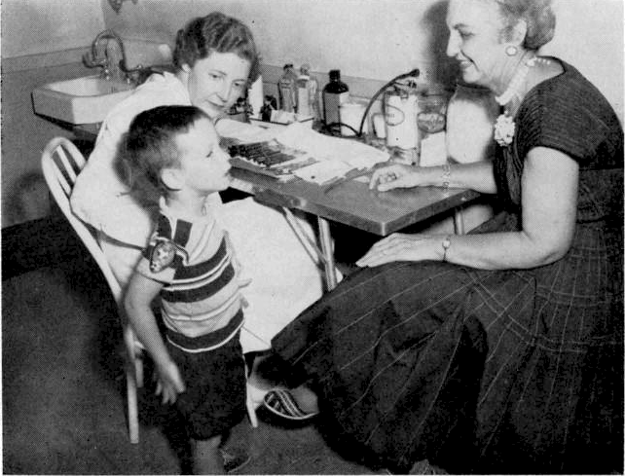
. THE COUNTY I•{EALTH DEPARTMENT—one of many community agene ies that heip the Visiting Teache r he ip the ch i Id to beco me a who ie and who iesome persena lity

Each agency in the coiiiiiiunity has its o»'n function. and cooper ative planning amon g all will iiiean better service for the peuple. When the visiting teacher know's the functions of all the agencies, she will know how to use the resources of her com- munity to the best advantage. She z'ill know where and how to refer families who need help. Likewise, when agencies know the ftIlJction of tfic visiting teacher and the kinds of problems n'ith u hich she can u ork, the; can make appi•opi iate i eferi'als to her.

i 11)

CHAPTER Hl

The Visiting Teoc&er oncl Her Colleogues
9’herever people woi•k together the together" part of the relationship is as important as the “work” part. The school staff is a team and each member establishes his own i•elationships with all other members. Much could be said about the great im- portance of all these relationships. This discussion is limited to ways in which the visiting teacher “works together with” each member of the team. Ways iB which her z orking relationships extend into the community have been noted in the previous chapter.
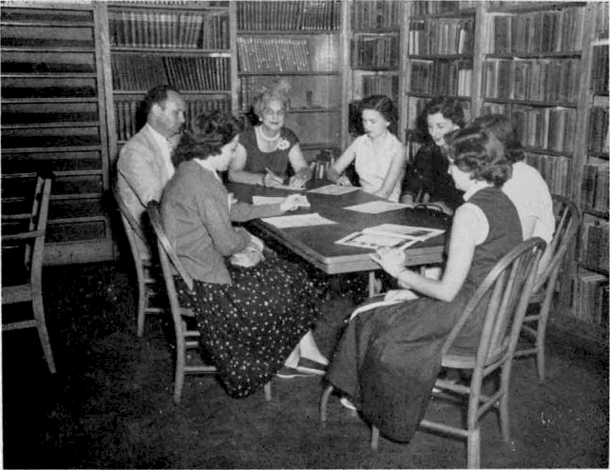
... the Visiting Teacher brings her facuTfy colleagues new undetseandings from the community

The visiting teacher needs to know and to be known by all other school personnel and to establish ways of working with them. She needs to know the limitations of their duties and they need to know hers. She needs to know the principles of working with other people and continually to examine her practice of
(18)

these principles. This is basic to all professional relationships. In addition, she must work out her relationships with other staff members in terms of their own particular functions and hers. '1’ho.:e are the working relationships uhich insure an effective rOgrarn.

\ñ/hat‘s the Visiting Teacher Like as a Person?

An examination of personal attitudes and motives is essential in z orking with others. It is not a personal service, but the visit- ing teacher does necessarily function as a person. Being profes- sional does not mean being aloof and impersonal. It does mean that personal feelings, desires, and prejudices are not allowed to interfere with working relationships.

rJhe visiting teacher must demonstrate her right to accept-
ance and respect by giving service of high quality and by being 1.he kind of person with whom others can work. She must be az are of the weaknesses of the school, but she must not lose sight of the fact that she herself is also a part of the school. For maximum effectiveness the visiting teacher must possess not only an understanding of the purpose and scope of the program of which she is a part but also have a genuine love for children and a fufl awareness of the value of this service to them.
The visiting teacher does not assume the role of any other person on the school staff. It is true that her role will be de- termined to a certain degree by other kinds of services available, but hour program cannot be expected to compensate for the lack of other facilities. For example, she cannot take the place of a school health nurse or a mental hygiene clinic. 0n the one hand, there must be reasonable limits to what she is expected to do regardless of other resources, and, on the other hand, there should be enough flexibility to allow for the best possible service to children in the local school system.
In allowing for flexibility in the visiting teacher's duties there is danger that the school may find itself with an errand girl instead of a professional worker. This can result not only from the many and varied requests of school personnel but also from the insecurity or the visiting teacher in the fear that she may not be able to establish a place for herself. Limitations will not prevent her acting on her own natural impulses of good will or giving freely of her time in an emergency as all conscientious workers do when occasion demands. The visiting teacher who has time to work for everybody else is saying that her ow'n job is not so important. 'rhe one who cooperates generously as its fits into her schedule and does not take away from the total service to children is serving as a good member of the team.

(19)

All school personnel should share a mutual and not a corn petitive interest in children. The school exists for the child and not for the staff. Not the attitude, “This is my territory; you stay out!” but “How can we work together' to make the school a good place for children?” should be a professional motto. In such an atmosphere, which she has responsibility to help create, the visit- ing teacher can set up a good working plan.

How She Works with fhe System Superintendent and
Board o0 EducaGon
The administration sets the policies for the entire system and the visiting teacher is responsible for carrying out those set for her own program. She is also responsible for making reports of her work to the local superintendent or board as z ell as to the state. When the types of duties are specified in detail, the responsibility is clear. When she is left to her own initiative ex- cept for very general policies, she still has definite responsibilities. She will need to make at least occasional reports of her activities, both statistical and narrative. She will participate in reports of the school system to the community, thus contributing to better un- derstanding and good public relations. As there is need, she may want to ask the local superintendent or board of education for specific policies to guide her in certain kinds of situations. For instance, before she refers a ease to court, she should know the attitude of the superintendent and board of education. Con- ferences with the superintendent or his delegat-•d representative on matters of policy and general development of the program are important.

How She Works with the Principal
The principal is the head of the school and responsible for what happens there. AH contacts with his school should be made through him or with his knowledge. The visiting teacher works cooperation with him and as a member of his faculty when she
is working in his school. Ice should be consulted about policies and procedures in his school and should be kept informed of progress in the areas in which the visiting teacher is working. He helps interpret the function of the visiting teacher to teachers and to the community and helps the visiting teacher know of referrals that should be made in his school.
Methods of referral should be agreed upon whether all should come through the principal or clirectly from the teachers. In either case, the principal should know which children are re- ferred and why. He should know at so of continued iv ork with these children because all plans for working with a child in trouble
(20)

should be coordinated. With shared planning the principal, class- roomteacher, and visiting teacher can work more effectively toward a common goal.
It is important for the principal and visiting teacher to work out together the best way to help all children in the school be- come acquainted with the visiting teacher in such a manner that she will be accepted as a natural part of the school and children will not reel embarrassed or reluctant to see her individually. This is a continuing process. Children should know that the visit- ing teacher is a part of the regular staff.
Any new plan or significant change in regular routine in a school which the visiting teacher wishes to make should be dis- cussed first with the principal. He may have valuable suggestions to make or know of reasons the change should not be made. He may invite the visiting teacher to a Faculty meeting where plans and policies can be discussed.
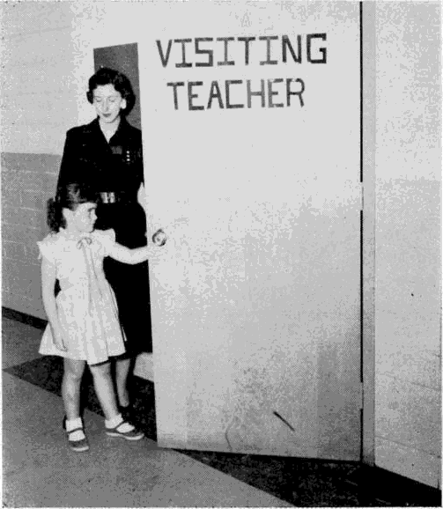
. . her friend, the classroom teacher, brings her fa another friend

(21)

How She Works with the Classroom Teacher

The principal is the key person in the school with whom the visiting teacher plans first for the whole school, and the class- room teacher is the key person to the children in her class. It is of the utmost importance that the visiting teacher work closely with the classroom teacher. This means that teachers must know referral policies and other plans for the visiting teacher's worx in their school. All teachers need to know the service so that referrals can be made whenever necessary.
The teacher is the most important person in the child's school adjustment. The visiting teacher does not take the child away from the teacher nor does the teacher hand him over to the visiting teacher to solve his problem. While the visiting teacher must establish a warm relationship with the child in order to gain his confidence and help him, she also tries in every way she can to strengthen his relationship with his teacher. Her relationship is temporary and lasts only as long as the child needs her help, while the teacher lives with him day in and day out. When both teacher and visiting teacher have equal concern and an equal share in helping, the child derives the most benefit from the service.
Conferences. Since frequent conferences with the teacher are important as the visiting teacher works with the child, definite plans should be made for them. Interruptions of classes should be avoided as much as possible. Standing outside the classroom door is not the most satisfactory place for discussing a child or talking with a child. Face to face contacts mean more than written reports, though it may be necessary at times to report to the teacher in writing. Conferences are necessary to share informa- tion and plans.
Sharing. ’I'he sharing of information is an important matter. When all concerned with helping the child pool their knowledge, the best results are accomplished. If the teacher withholds per- tinent information about the child, the visiting teacher will not be able to proceed as well or as quickly. When the teacher has shared information fully, she has the right to expect the same professional consideration she has given. She should be given pertinent information regarding a home visit or interview with a child as soon as possible. A referral is a request from the teacher for help in her own planning for further steps with the child r.s well as a request for additional personalized help for the child. The blending of the two purposes will result in the most benefit to the child.

(2t)

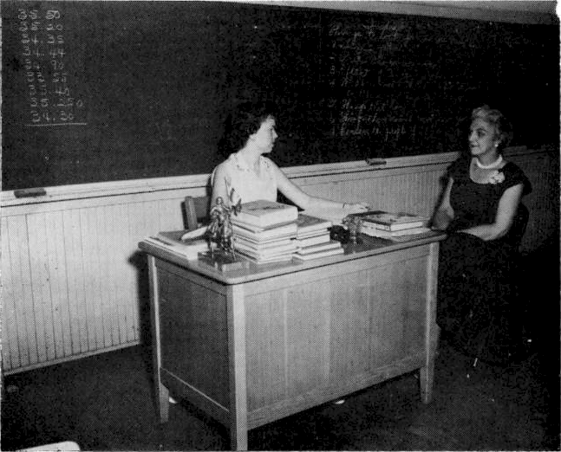
. . fhe classroom teacher and Visiting Teacher share and plan in their toInt responsibility — fha child
l'i erttien t l3’ the question arises as to the kind of infor ination that shoiild be sliai ed. Should the visiting teacher report to the teache i’ con fittcntial inf or ination a chilti oi’ parent has asked her not to te11* lt is obvious that one should not violate a confidence: yet many t i)ucs it is information that would be helpful to the teacher to know'. 3’hen the visiting teacher should talk with the child or parent about what the teacher needs to know in order to help the child. She should gain the child's or parent's consent. or if objections are raised, work with them about the i importance of sharing infor ination z'ith soiiieone else. If thci e is cei tain in- (or iratio' u hish the teacher must know’ iiiiinediately, periiiissioii of the ehilti is not asked, but the i'eason should be explained to hint. It is better tt› proceed slfiw'ly than to destroy a child's faith iii the person who is ti'jing to help hint. It is i mpoi tant for’ the child to know that his team her, his parents, and the visiting teacher arc workin g togctliei to hel p him and that they iiiust share in- foi-iiiati‹›ii in orcle r to help.
Sonieti mcs the parent tiiibttrdciis feelings to the visitiii g teache i’ u hich aide ii(›t pertinent to the preseii t proble in, inii!iiiig it iiiiiiccessar› io iiiention thein again, just as the teacher tliscusse s

factors which need not be repeated to the parents. Sharing in formation does not mean telling everything that happens. Two rules can be of great help in deciding what to tell reach agree- ment with the persons giving the information as to the part that would help in solving the problem, and use it in a positive way. Instead of saying, “The house is so dirty you could not expect the child to be clean,” report that it is easy to understand the child's difficulty after seeing the house.
Basic to any policy of sharing information is that each party is the kind of person who can be trusted professionally. It is easy to understand why the teacher who asked for help in checking a malicious rumor about a high school girl decided never again to refer a case when the visiting teacher began to repeat it in the community. Also, a visiting teacher will carefully avoid giving any confidential information to a teacher who remarks, “If a mother won't do any better for her child than that, she need not expect me to try to help him!”
Deciding on Referrals. The teacher has a very important role to play in preparing the child to see the Visiting teacher. He should be told why he is asked to go, and the visiting teacher should be introduced to him as someone who is a friend and can help him. Discussing the problem with the child or saying to him that she thinks the visiting teacher might help find the cause of his prob- loom in school will take him a long way toward its solution. The visiting teacher should never be used as a threat or a punishment. Ideally, the teacher and child decide together to ask the visiting teacher to help.
There is no reason for the teacher to feel that she has failed or that she is inadequate if she refers a chila to the visiting teacher. It has been noticed repeatedly that the best teachers make the best referrals wheE they understand the function of the visiting teacher. Sensitivity to a child's needs and choosing the ones who need special help make of the referral process a professional skill. When a boy or girl shows special talent in music or art, the teacher tries to provide opportunity for growth in these fields. If a pupil seems to need glasses, she may refer him to the school nurse. When he is unable to make or keep friends, she may ask the visiting teacher to help him. Neither the teacher nor the visiting teacher can guarantee success. They do not do things to a child or for a child but help him work out things for himself. The child himself is the most important factor. One eighth-grade teacher referred a boy because he was a per- petual annoyance and would not work. The best efforts of teacher and visiting teacher did not help him to change. Several weeks later his behavior and school work suddenly became better; he had become interested in a classmate who encouraged him to conform to the standards of the group.

(24)

“He May Gel Worse.“ One important factor to remember, especially in serious problems, is that the child may get worse before he gets better. Talking about a difficulty makes it more acute ñut, at the same time, is the best way to face and overcome it. Understanding this will help teacher and visiting teacher to accept the regression and to continue to work with the child. For instance, the little girl who is stealing pencils may feel so guilty that she steals more often until she can understand herself and why she has adopted that kind of behavior.
In attempting to help a child the teacher and visiting teacher must consider the child's capacity to grow, to become more mature. Not every problem has to be solved with their help. As he learns to manage the one for which he was referred, he may gain understanding and experience to handle others alone. Some- times the healing power of time is all that he needs. Several months after active work has ceased, or after a summer vacation, the teacher may discover that he is like a different child.

While relationships with all members of the school team are important, the one most significant factor in helping a child is the working relationship between his teacher and the visiting teacher. Oi equal importance to the child is the relationship established between the visiting teacher and his parents.

How She Works with Other School Personnel

The basic principles of working with other school personnel arc the same as working with principals and teachers. The super- visor, counselor, school nurse, psychologist, or any other member of the staff has his own area of work, limitations, and responsi- bilities.Ln worming together to understand each other's duties, cach talking his own part of the responsibility and clarifying mat- ters that overlap, all will become a team. Bus drivers, lunehroom workers, building custodians, all who are a part of the school should be included.

(25)

CHAPTER IV

, not u were yaw hecioy

Let‘s Get Down To Cases
What IS Casework?

Casework is a specialized skill used to help individuals sold, t' their own problems, a way of understanding and working with people in a one-to-one relationship. It is not merely gathering facts about someone in order to understand him better or giving information in order to help him. It is not going to the home to get information that will help the school or taking messages from the school to the home. It is the process of helping in which many techniques are used.

no man ic i ri'cbs’
Ways of WorLing With Children
There are no sets of tools, no magic tricks, which may bu called “techniques of casework.” There arc ways of working with people which have been found to be helpful. ’l'hese methods are described in an effort to answer some of the questions and per- haps clear up some of the misconceptions about casework.
The Interview. Interviewing as a paTt Of the casework process is a learned skill which is improved through study and practice. It is not “just talking” nor is it giving advice. Talking is the major means of communication used, but the talking has a purpose which both the visiting teacheI' and the child understand. There are many other means ot communication u°hich both use in the interviewing situation. The visiting teacher observes the child‘s mannerisms, facial expressions, posture, and general attitude. What he omits is as important as what he tells. Whether he is habitually late or early for appointments is significant. With a child, the use of play materials helps in the expression of his feelings. He may act out what he is unable to verbalize, or he may be more at ease when his hands are busy. Noting what makes him appear anxious, change the subject, or stop talking is a useful technique. The more alert the interviewed is to all that is happen- ing, spoken and unspoken, the better able she is to carry out her own part of the interview.

(26)

The Relationship. Help and change take place through the skilled, sensitive use of the relationship between the two persons involved. The first steps in interviewing are planned to build relaUonship of mutual trust and confidence, of understanding and the freedom to express deepest feelings without fear of condem- nation. The relationship is meaningful and very real to both. In this atmosphere the child is free to work on his problem and the visiting teacher is free to help him. It is something both use con- sciously and unconsciously.
The visiting teacher must be aware not only of her own use of the relationship but also of the child's use of it. As work progresses and the child faces his problem more and more deeply, varied reactions are likely to occur, such as dependence on the visiting teacher, hostility, rejection, guilt feelings, or others. De- scription and explanation will not give the full meaning of the relationship. It must be experienced to be known fully.
Acceptance. Acceptance is of major importance in the case work process. The visiting teacher accepts the child as he is, begins working with him where he is, and proceeds at his own pace. She does not judge him by her own standards but allows him to be himself. Acceptance must be real and sincere; there must be genuine liking for the other person. It is entirely possible to like a person whose standards are not accepted and whose be- havior is not approved. With a child, especially, it is of the utmost importance to let him know he is liked whether his behavior is accepted or not. The child will know it if the visiting teacher does not like him. Friendliness and a non-judgmenta1 attitude are es- sential in helping.
Other Techniques. There are other important techniques in casework service. Listening while the other person tells his story in his own way is valuable. Knowing when and how to ask ques- tions is one of the most important. The interview is not a quiz. If certain information is needed, the child should know what it is and why, also how it will be used. Gathering information which is useless is a waste of time and may be harmful to the child. The visiting teacher does not probe into the child's own private affairs or his feelings by asking questions which are irrelevant to the situation or which he is not yet ready to answer. If he is pushed too fast ,he may break ofi the relationship and leave his source of help. There must be a sincere desire to understand and help h'm, a feeling which will be communicated to him in all that the visiting teacher says and does.
The helping person is as much a part of the casework process as the person seeking help. It is what happens between the two and how the child uses it to *hange that is the heart of the entire
(27)

helping situation. The visiting teacher must know how to involve herself as a person, how to be warm, friendly, sincere and in- terested, without allowing the interview to become a personal conversation. The visiting teacher's own personal affairs and feel- ings are not discussed; otherwise, there would be two clients and no helping person.
The visiting teacher does inevitably have feelings about what is going on, but she must know how to handle them so that they do not get her involved personally in the child's problem. She does not merely listen while the child relieves himself by talking or playing. Her responses, attitudes, questions, sincere interest and attention are a vital part of the interview. She must be keenly sentitive to the child's feelings and help him understand what is happening to him. She does not take the problem away from him but helps him handle it, respecting his decisions. She also respects herself and trusts herself to become a vital part of the relation- ship. She invests a great deal of herself in it with an awareness of what she is doing.
Understanding human behavior is another tool which enables the caseworker and the teacher to be more helpful. Knowing the general characteristics of children at different age levels is useful in determining whether certain behavior patterns are normal or abnormal for the child concerned. To recognize that all behavior, good or bad, has a cause is to understand that the unusual re- actions of the child or adult are symptoms and not the disease. The bully may be covering up his own cowardice; the angry person may actually be fearful. Behavior is not understood in the ab- stract, however. Certain conditions do not cause specific kinds of behavior as the typhoid germ will always cause typhoid fever instead of malaria or some other disease. Instead of one cause for certain behavior there is usually a combination of many causes which are different for each individual.

How Is fhe Visiting Teacher Trained?
Study in a school of social work is considered the most valu- able specialized training for the visiting teacher. There she learns casework methods through class study and actual practice under competent supervision. There are courses in understanding normal and abnormal behavior, human emotions, and the de- velopmental stages of growth. The visiting teacher learns to understand herself better, some of the reasons she behaves as she does, and how to handle her own feelings in a better manner. In brief, this kind of training enables the visiUng teacher to work with people in a more helpful way.

(28)

Vet, social work training does not guarantee the most com- petent service nor does the lack of it prove that the program is superficial. Much of the success or failure of the work lies in the visiting teacher herself and in the administrative set-up. The visit- ing teacher feels her own need for more understanding and skills that come from more specialized training, but she uses what she has already learned from her previous training, experience, and actual living and continues to learn more as she serves people in the helping process. In-service training is being used to help increase the knowledge and use of casework methods and to help the visiting teacher feel more secure in working with people to help solve their problems.
If the visiting teacher’ has not had the opportunity for specia lized training, the school need not feel that she is unable to help people, The skillful service that numbers of people have rendered who began work with no special training is proof that it can be done and is being done. h'o professional person, with or without casework training, should attempt more in the area of human relations than she feels capable of handling. Trust in herself and a sensitivity to the feelings and needs of others, together with an objective attitude, will enable the visiting teacher to carry out a capable, professional job. Availing herself of every opportunity to learn as she uorks will enable her to be of more and more service to the school.

”V'ith and not for nrales a di’0erence”
CHAPTER V

The Child Himself

The focus of all visiting teacher work is on the child. The work begins with him but may reach out to all the significant people and things in his environment. Beginning with the child makes him a real part of the plan to help him and serves as a stimulus to him to begin woi k on his problem himself. Most adults grossly underestimate the ability of children to understand themselves and the causes of their behavior, also their strength to do something about it. Whether due to lack of understanding or to the need to keep children dependent on them, this attitude on the part of adults interferes with the child's growth toward maturity and independence. Children are not trained as animals are trained. They are not “conditioned” to good behavior and
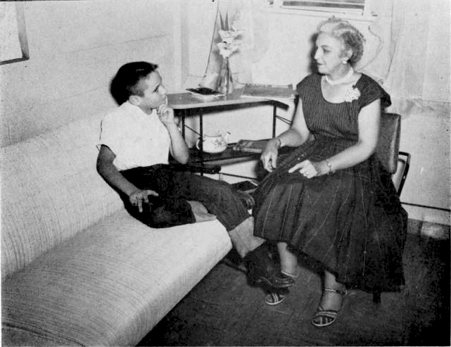
... The Visiting Teacher supperts his strengths as he works on his problem

(30

the right social skills. They are thinking, responsive personalities actively participating in their own growing up. More “working with” and less “working for” the child on the part of all the team will lead to fewer school problems.
Face fa Face
Getting the Child in Focus. It is not possible to over-emphasize the importance of working with the child, including him in the planning and the activities related to the need to change his be- havior. It may seem simpler and less time-consuming to make plans for him, to work around him, or to punish him for his bad behavior, Dut these do not solve the problem. It is treating symp- toms and not causes. Punishment may deter the impudent youngster from “talking back,” but it will not give him the respect and trust of adults that he needs; he will have to find another symptom to express his feelings. Why did the girl who appeared shy and lonely not seem glad when told that all arrangements had b•.en made for her to go to camp? She had not been included in the planning and camp may not have been what she needed. Ignoring the problem, Ialse reassurances, helping the child to forget, and “making it up to him” by over indulgence are not steps toward maturity. Facing problems ith him as he is able to lace them without blame or censure is mature action toward him and the nay to help him grow in his own best way.
It is through the casework relationship that the child is helped. Regular, planned interviews are the most effective means of accomplishing this end. Whether there is one interview or many, there needs to be a plan, a time, and a place. The reason should be explained to the child at the time of referral, not simply that the visiting teacher wants to see him in her office. If a schedule can be arranged so that the child can remember his own time and keep his own appointment, it is even more helpful.
Standing on His Own Feet. While working with the child is the focus of the service, the ultimate purpose is to enable him to get along without special help. He and the visiting teacher, together with his teacher, decide when that time has come. The visiting teacher z orks toward strengthening his relationship with the teacher and with the group. ’the teacher is the parent hgure at school and children tend to act and feel toward her as toward their parents. The high school girl who talked at length about how one teacher always mistreated her finally said, with obvious sur- prise to herself, “She acts just like my stepmother!” When she understood her own tangled feelings, she no longer was antago- nistic toward the teacher. The little girl who said to the visiting teacher, “My teacher likes me now,” was rejecting her own changed feelings.
(31)

Often the relationship z°ith the tcacher is good, but the dif- ficulty lies in getting along with his own group. It is essential for children to feel accepted by thcir peers. A ten-year-old boy was referred to the visiting teacher because he had a fight very day in school. Within two months he was captain of his bah team. He had realized his anger at an older brother for being the favorite at home, and at the same time, his mother had been helped to give him more attention. Helping the child understand his own feelings is basic to changing attitudes.
Choices. Most often the child does not come to the visiting teacher of his own accord but is referred by someone else, usually the teacher. Here the school setting is definitely an advantage. He is accustomed to the authority of school, and, since the visiting teacher is part of the school, accepts the service as he does other sehool serviccs. This does not mean that he neill always like being sent to the visiting teacher. Preparation for referral may help him to accept the visiting teacher in a more positive way, but he will still decide for himself what he thinks of the experience and how he will use it. 2’hough he may not have had a choice in coming, in a very real sense he decides whether he will use the service. This is a part of the casework proces talking with him about his feelings in coming and letting him know that he does have some choices.
Not all choices can be left to the child, of course. There arc certain limits within which both he and the visiting teacher must operate—the rules of school, attendance laws, ar.d the demands of society. It should be made clear to him what the choices are in the situation. He makes his decisions within these limits. No amount of “help” can get him to learn to read unless he partici- pates in the process. No plan will work unless he helps make it work. One fifteen-year-old boy, who had been truant since the first grade and had resisted all efforts of the school to help him change, finally was able to say to the visiting teacher after pro- longed work together that this was the only way he would hit back at his parents for hurting him (neglecting him). Then he retreated behind his wall of defense again, saying that it was too late now to change; it would mean that his parents would win. He would prefer to endure school untíl he was sixteen years old and could quit rather than to give them the victory. He had made his choice and no amount of effort on the part of the visiting teacher could reach him to help him see what he was doing to himself. If he haó been referred in the first grade, the story might have been diíferent.
Actually giving freedom of choice to the child when it is possible makes it more likely that he will make good decisions. lnstead of telling him he is expected to go to school, which he

(32)

knows already, ask him what he is ready to do about it or what things get in his way of liking school. Instead of setting a deadline arbitrarily, let him decide when he thinks he can get himself back to school.. Too often the pressures of the school for a good atter-dance record or her own desire to get results cause the visiting teacher to pass that pressure on to the child and his family, while proceeding more slowly and allowing the child a chance to change himself could possibly be the means of a better attendance record in the end. The same principle works in other areas, too. If the child is angry when he comes to his interview, he can choose whether he wants to stay and talk or wait until another time. If he is angry about coming, there might be dis- advantage in his staying. If he is angry at someone else, he may welcome the chance to stay and get rid of his feelings.
Testing the Relationship. Whether the child is willing to come or not, he will find ways of testing the strength of the relationship and the sincerity of the visiting teacher before he will risk re- vealing his deeper feelings. He must know he is accepted. The aggressive child may break a toy to learn the visiting teacher's reaction. The fearful one may hide behind the desk. This is the beginning of the casework relationship which the visiting teacher must handle consciously and with care. One nine-year-old who was skeptical of all adults would not respond to the visiting teacher's friendliness but suddenly seized her purse and gleefully emptied all its contents on the floor. When she did not scold or punish, saying she did not like people to do that to her purse but she still liked him, he stood close by her and asked to stay a long time.
Frequently a child will ask for something that belongs to the visiting teacher, even a piece of paper, to test her liking for him. Most children will ask who the other children are who come and what they talk about. This is not to find out what the others do but how the visiting teacher feels about children who coiiie to see her, an attempt to find out how much she likes them. Some children will be absent on the day the interview is scheduled; others will have to pass the door many times during the day to be sure the visiting teacher will not forget them. Many will declare that they had not even thought about the interview since last week, had forgotten it, in fact. Some will want to prolong the interview, others to leave early. Some will tell fantastic tales about their bad behavior, others deny that they have a problem. Every child will have his own special way of testing the relation- ship.
The Child's Own Strength, Xluch has been said about helping the child develop and use his own strength to solve his own

(33)

problem. How is this done in the relationship with him? Allowing him to make choices within reasonable limits is one way. Helping him to face the reality of the situation is another. Allowing him the freedom to make mistakes yet to be accepted, as well as to realize an adult believes in him, adds to his self-respect. A very important means of developing and using his strength is to work on a small part of the problem at the time. The child sets the pace and gives direction to the interview by revealing his readi- ness to tackle the problem. These are some of the methods which help him to understand himself.
Examples will illustrate better than a description. Margaret was having trouble “taking things.” the first step was to help her see that she took things only when she was unhappy, but it did not make her feel better; it really made her feel worse. The next step was to explore the many events in her like that made her unhappy. Finally came the day when the visiting teacher asked if they could make a plan about what she could do the next time she felt like taking something. After deep thought Margaret de- cided she could tell herself to go away from it and leave it alone. The visiting teacher remarked that this would really be her de- cision because nobody else would be there with her. She was sure she could do it. And, for the first time, she did go away and leave things alone. The next step was to help her plan ways she could feel happier at school. She decided that if she did more school work she would not have so such time to feel bad and could feel glad about better work. This was the process by which she overcame the stealing entirely. Each decision was her own idea worked out with the support and understanding of the visiting teacher.
Sammq had tLie
stomach ache
Another example is Samniy. A highly intelligent sixth-grader, lie began to have a stomach ache every day during arithmetic class, asking to go to the sick room. When he began begging to stay at home, his mother took him to the doctor only to find that nothing was physically wrong. Sammy readily admitted to the visiting teacher that he knew it was nothing he ate, but his stomach did really hurt. She agreed that worrying about some- thing could make people feel sick whether they really were sick or not. She suggested that since he knew that much, maybe he could begin to find out what really made him feel sick. Finally he was able to say that arithmetic was not actually too hard, he
(34)

just did not like it. Then what could he do about that? He could work harder, but he guessed there was something else about arithmetic that made him feel bad. After intensive work on the idea, he revealed that he and his father had conflict every even- ing when he was doing his arithmetic homework. Next he con- nected this with the fact that his father wanted him to be an engineer while he himself wanted to be a doctor. Gradually he came up with the idea that he had several years to decide what he wouid be, bui his stomach ache was a way of running away from his problem. He could talk to his father about his wish to be a doctor. When he was strong enough to face his problem, he no longer needed the symptom of a stomach ache.

lO QS6fN P0f, £O
strengthen courage
Growing Up 1s a Big Job. In working with children it is im- portant to remember that many of their problems are in the area of growing up. Many times school failures can be traced to this fear. Learning is a sign of growing up; so to fail to learn may in some way postpone that fate or relieve the child of its responsi- bilities. A boy said he would have to marry if he grew up. Another, with a severe speech defect, was afraid of going to the army. A speech defect would keep him out and keep him from making progress in school. Another child had a relative in jail and feared the same fate for himself. A mother was making her daughter feel guilty about wanting to be independent and was using illness to tie the girl to herself in a morbid way. A little girl was crying every day at school because she wanted to be at home with the baby, the favorite of the lamily. The complexities of growing up constitute one area in which the visiting teacher can help children to gain strength. If they can see the obstacles in the way, the things that make them afraid to grow up, they can learn to handle those feelings in a more mature way.
\k’hen ihe yoi'ng gels
rough, a rri”end
The Heart of the Service. Working with the child is a specia- lized area of casework. It requires special skill in understanding growth and development, in respecting the child as an individual, and in developing an understanding way of forming a warm re- lationship in which to work. The child is not a case but an indi- vidual. He has the right to understanding and help from the adults in his life in the business of growing up. He needs the teacher all the time at school and the visiting teacher when the going gets too rough and he and his teacher wish to ask her to help.
(35)

CHAPTER VI

mhecruec tbe child gOes,
hi's problems go

The Child's Fomily
Some of the most effective work of the visiting teacher in helping the child is done with his family. The child does not have one personality for school and another for home and other places. He takes all his problems with him wherever he goes. At school he may be worrying about a quarrel at home; at home he may be worrying about arithmetic or what the teacher said. Most parents have a more vital interest in their children than anyone else has, and all parents can be found to have some concern. It is of the utmost importance that parents be included as a real part of the working situation when dealing with the problems of their children.
not hi ding t hinqs”

When and Why the Fami ly Is Important
Though work is begun with the child, it is almost always necessary to contact the home either by a visit or by inviting the parent to come to school. In certain instances when adolescents are struggling to become independent and the problem seems to be in themselves rather than in the faintly, it may be better to work with them individually. In other instances when there is only one contact with the child or the problem is of a very minor nature, a visit to the rome might create a problem rather than solve one. There are other situations when the home should be contacted before the child is seen. If trouble seems to stem from a misunderstanding between parent and school, or if it is known that it is the situation itself which is causing trouble for the child, or if the problem involves all of the children in the family who are in school, the first step would naturally be to contact the home. The nature of the problem will always determine the procedure. It is not a matter of hiding something from parent or child or or developing routine methods of meeting situations; it is deciding the best steps to take to help the individual child.
Frequently the only contact parents have with the school is through the visiting teacher. As a representative of the school she has an obligation to interpret the policies of the school to parents and to help them find answers to their questions about specific situations concerning their children. The parents can be
(36)

of help also to the school by helping the visiting teacher to know their children better.
The purpose of home contacts is not merely to gain inforiiia- tion about or understanding of the child, though this is one of the important results. The real purpose is to work with parents con- cerning the child and his problem and their own problems as parents as these affect the school child who is having difficulty. In other words, a casework service is offered to parents in re- lation to the work with their children. There is the same accept- ance and understanding of the parent as of the child. The visiting teacher does not identify with the child against the parent or teacher nor does she identify with either against the child. She works with all in finding and removing the causes of the child's proble in. She works with parents because they are parents and have the natural right to be consulted.
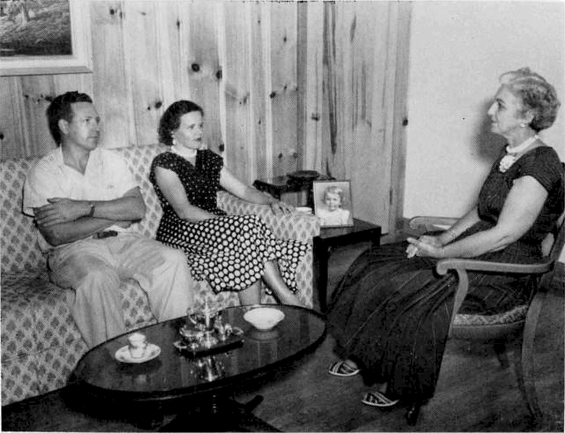
... parents and Visit ing Teacher find reasons for teara and tangles that bother the child

The visiting teacher and the parents work together on prob- lems associated with the child's difficulty. If there is another kind of service needed, she assists them in reaching the proper source of help.

How tf›e Family Helps

Just as the visiting teacher does not take the child away from the teacher, neither does she take him away from the parents not permit them to turn him over to her. She does not make de- cisions wkich belong to the parents or ofier advice. There is a mutual working together until a common decision is reached. If advice is given and either fails or is not followed, there is the tendency for each to blame the other.
Unless there is a specific reason for taking another person along and unless the parent knows in advance that another person will be present, the visiting teacher should go to the home alone. When two people go together to discuss a problem, it may seem

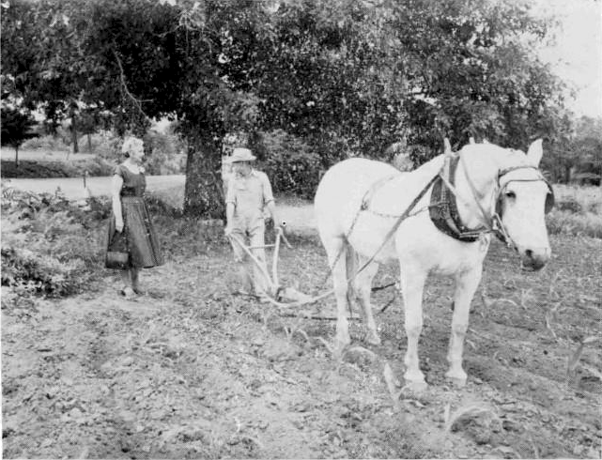
.... in field or a+Bee, the Visiting Teacher and the parent considat fhe child who concerns them both

to the family that an unfair advantage is being taken. The same principle holds true iI neighbors are present during a visit. If the neighbors insist on staying, it is better to make another ap- pointment than to discuss private matters in th•.ir presence.
(38)

“...noi to judge, no I fo
reform, hur Io help”

The School's Part in Helping the Child

The school should not use the visiting teacher service as a means of telling the family what they should do. Parents appreci- ate no more than the school being told what they must or must not do. While teachers and visiting teacher may feel that certain parents are not taking enough responsibility or interest in school matters, the only way to change the situation is to try to find the cause, to know what the parents think about it. They may feel that the school is not su&ciently concerned about their children. The visiting teacher may be of real help in establishing home- school cooperation when this has been difficult. It is important to remember that the children in school come from a wide variety of homes with many different standards of living but representing a more or less satisfactory way of life for the family itself. The purpose of a home visit is not to judge or to reform but to help.
When parents know this is a service they can request, they can feel free to come to the school or to ask the visiting teacher to come to the home. Many parents prefer seeing the visiting teacher at school; it involves more active participation on their part. After all, they are vitally interested in what happens to their children and are naturally concerned.
Parents may wish to talk with the teacher about the referral. Teachers can help parents understand the service as a part of the school. Even though they may have known about it, there is al- ways a different feeling when it is related to them personally. All people have some anxiety about a new experience, and parent° have a right t0 know the approach the school makes to the probe lems of their children. Teacher and visiting teacher have a joint responsibility to explain this to the parents who will be using the service.

(39)

CHAPTER VII

Preventive Aspects of the Program
The. school seeks to create a healthy emotional atmosphere for children. Fewer educational casualties result in a setting where the child rather than the textbook is of primary importance, One of the major responsibilities of the school is to work with children in such a way that they will not run into difficulties either academic, social, or emotional. The visiting teacher carries part of this responsibility for prevention. It is in this area that some of her most effective and far-reaching work can be done.
Preventive measures are as important in mental health as in physical health. Everyone shudders at the thought of exposing children to whooping cough or polio or even the common cold. Yet it is as damaging to the personality to be exposed to nagging, harsh treatment, jealousy, anger, gloominess, irritability, or hatred as it is to the body to be exposed to a crippling disease. If companions are critical, gossipy, untruthful, pessimistic, or quarrelsome, a person may soon find the same traits in himself. On the other hand, cheerfulness, fair play, friendliness and a happy disposition are equally as contagious. The school which creates such an atmosphere as part of its curriculum has a good preventive program in mental health.
Early Symptoms
The secret of a good preventive program is the recognition and intelligent handling of early symptoms of trouble. The school is the one institution in modern society which comes into contact with all children. This fact becomes even more significant when it is realized that the contact is maintained during all the forma- tive years of the child's life beyond early childhood. Because this is true, there is no better place than the school in which to dis- cover and make plans for overcoming the first signs of difficulty. 'the school is the setting in which all children may be reached most easily and naturally.
Strategic Position of Teachers. Teachers are in a better posi- tion than anyone else outside the home to observe the daily be- havior of children and to recognize when they are meeting diffi- culties which interfere with their normal development. Here, more than in anY other area, can close cooperation between teacher and visiting teacher be most effective and results most immediate and permanent. In planning the use of the visiting teacher service the urgent and deep-rooted problems should not

(40)

be allowed to crowd out the less urgent. Many preventive cases can be handled in the same time required by one difficult and involved situation, although neither should be neglected.
All children experience problems as a part of growing up. There is neither wisdom nor kindness in trying to protect them from all difficult or unpleasant situations. Only as they can be- come able to manage frustrations in small doses with wise and loving guidance will they be prepared for the reality of living. Children are equipped with strength to cope with a great deal of frustration. Just as the human body tends toward physical health rather than illness, so does the personality tend toward mental and emotional health.
It is important to distinguish between normal behavior and signs of trouble. Not every child who misbehaves or fails to con- form to the group is emotionally disturbed. The first grade child who does not play may not be anti-social but may be lacking in the experience of playing u°ith others. A timid child may live in an isolated community deprived of associations outside of his family. The uninhibited trouble-maker may have had too few restraints or too many indulgences. ñlisbehavior sometimes may be resistance to adult standards and rules which are too exacting, or perhaps a test to sec what adults will do. Most children have heard their parents or o1:her adults boast about how they dis- obeyed the rules in school. Yet, even with the best intentions, all children will make mistakes occasionally. They lack the wisdom and maturity to make the right choices always.
How to Know? How then can adults know what is normal behavior and what is an early symptom of trouble? There is no sure way, but one of the best guides is to know the child's general pattern of behavior. Does he usually have a sunny disposition but suddenly becomes irritable? Is his usual participation replaced by withdrawal from the group or day-dreaming? Is he more in- clined toward exaggeration and “tall tales” than he should be at his stage of development? Is he unable to assume proper re- sponsibility for himself? Is he beginning to dislike school? Is he becoming overly independent or dependent for his age? The child who steals may have a deep-seated problem or he may never have had anything of his own; everything may have been shared at home, including the family drinking cup. Close observation of the children in her room enables the teacher to know when a child seems to be adopting a kind of behavior which is different from his usual pattern and might be the first sign that he needs help.
Circumstances in the child's living situation may give clues to his feelings. Wearing a ragged dress, a “dress-tip” suit, or a different style of clothing causes children to look different, feel
(41)

different, and then act different. Being over-age or under-age, too large or too small, awkward or clumsy may cause children to feel out of place or too different. Non-cooperative or overly solicitous parents may interfere with the child's adjustment to the group. Reactions to such circumstances may be signs that the child needs help to adjust to the situation before he develops more serious symptoms.
No attempt has been made heTe to compile an exhaustive list of conditions which may be early signs of trouble for children. These are only suggestions of possible danger. Every child is different and will react to circumstances in his own way. ln general, however, any significant change in a child's usual pattern of behavior in a negative way is a signal that trouble may be developing.

What To Do?
The teacher is able to alleviate many difficult situations for children as she plans for individual differences in her class. Through closer oDservation in regular activities she may be able to discover the cause of the unusual behavior. Helping the unruly youngster to find satisfaction in cooperation rather than in dis- obedience may be the treatment needed. It is important to re- member that it is the cause and not the symptom which should be treated. Not all lying stems from ihe same cause. As often hap- pens, a situation may work itself out and the child return to his normal adjustment without the cause having been discovered. Then it may be assumed that the child overcame it through his own strength and the usual guidance of the adults in his life. In other instances, the child is not able to work out satisfactory solutions to his problems for himself nor can the teacher reach the cause in the classroom situation. These are the ones who need the joint cooperation of the teacher, the visiting teacher, and the home.
While the child must be a part of every plan made for him, the circumstances of each case will determine whether it is the teacher or the visiting teacher who works out the plan with him.
He 1s Hot “Bad.” One of the most important factors in pre- vention is that the child is not made to feel that he is bad because he has a problem. It is tragic to label him as bad and more dis- astrous for him to believe it. I(e can use that belief to justify his behavior and his feelings of hostility—if he is bad, it will not matter how he act.s anyway. And once he believes it, he must prove it to himself and to others.
Sometimes children feel that they must be good to be loved.
Then, when something happens to make them feel rejected, they
(421

array feel it is all because thcs’ ai'c ball. "1 hei'efoi e, it is very iris- portant that childrcii know they’ ai e loved u'ficther their behavior is approverl or not. that their behavior may be bad but the› thcinseii cs ai e not bad. It is liealtliy for thein to know' that, iv'hile they are accepted, their bad behat ior u'ill not he tolerated. In fact. pi'otcction f rorn li.cii’ on ii bad behai'ior u'ith jrist measures
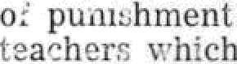 of t he love of parents oi
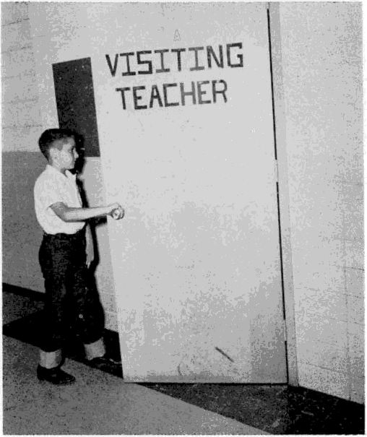
. he k nows where to fi nd h is fr iend, the V is it ing Teacher

’I he u'ay chilrlreii feel about the misc lves, their home, their school. and t heir’ coiiiiiiuiiity is the iDost i important Iac tor in de- terniinin g w hether they get into Irouble oi not. 4’here is no better preventive iueasri i e t hair hel pin g t heiii to feel that they are loved and 'antcd, thai t lied’ ai'c i iiipoi'taii t to the gi oup and belong. ’teacher and visiting te;lt‘hei play an iinportant role in this process.

Adolescence. The earlier a problem is discovered the more likely is the treatment to be successful. Concentration of efiorts in the primary grades can prevent many dif5culties later in school. Not all problems begin in the early years, however. Symptoms sometimes âo appear first at adolescence. Or, a sudden extreme event may reactivate a situation within a child that he could handle under ordinary circumstances at an earlier stage o1 his
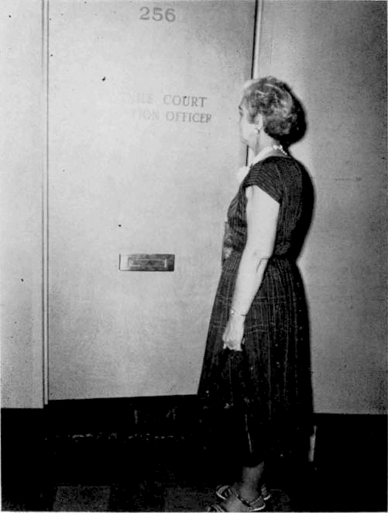
. .. "a bulwarL against juvenile delinquency—the Visiting Teacher program," seid e Georgia lagislafive commiwee report

development when conflicts about himself were not complicated by changes social, emotional, and physical which occur at ado- lescence. The school should be alert to the problems children are not able to handle alone at any age so that they may not become more serious.

(44)

SeIf•Referrals. In a school system where all the children know of the service and are free to ask for it themselves there is excellent opportunity for prevention. Self-referrals are more like- ly to come from those who know the cause of the difficulty, or who have experienced help before, than from those whose prob- lems are very deep-seated and involved.

It is good administrative policy to encourage self-referrals throughout the school. Invariably this raises the question as to whether some students will not use this as a means of getting out of class or for an excuse to talk about unimportant matters. Un- doubtedly a few students will, but it need not prevent the use of the policy. The mere fact that it does occur is an indication of a difhculty which the visiting teacher can recognize and help the student to face. The z•ish to get out of class on a flimsy excuse is a sign that he needs help. There will be those too who come from curiosity or the sincere desire to know and use all the school has to offer them. This affords a good opportunity for interpretation without making the child feel that he has done something wrong. The policy of self-referrals can be used successfully only when students, teachers, and visiting teacher feel comfortable about it.
The Child Knows lt. When a child is referred as a matter of prevention, the question often arises as to whether he should be told that he has a problem. fIe does not have to be told; he knows it. He may not be able to verbalize it, but he knows that some- thing is not right for him. He should be told the truth—that the situation may get him into trouble if it continues and that the school z ishes to help him avoid that unhappiness. Ignoring a difficulty or trying to help the child to forget it only makes it worse, never solves it. The child deserves the respect and support of having someone face the problem with him as he is able to face it.
The Matter of Juvenile Delinquency
All that has been said about prevention in a general way may be said about prevention of juvenile delinquency. On the other hand, any child is potentially delinquent. A child in trouble is an unhappy child, one whose needs have not been met and whose delinquent behavior is his effort to adjust to his environ- ment. ’1’he other extreme effort for a more comfortable adjust- ment is complete wit,hdrawa1, giving up the struggle either as a recluse or as a mentally ill person.
Even though the same offense is repeated after every effort has been made to help the child, it does not prove that he is a “born criminal.” It does prove that the cause of the behavior has not been found, or was not found early enough. Someone has failed the child.

(45)

Befere lt 1s Too Late. Yhe pre-delinquents and many ot the delinquents are in school now, and they can be discovered— not to turn them over to the courts but to help them o •ercome their anti-social tendencies. No one specific act should label a child as a delinquent. The school can take steps to help him if he begins to show a trend toward belligerent, evasive, or other non-conforming behavior.
It is not enough to say that parents should teach their chil- dren at home how to behave. It is not possible for parents to do all of it alone. It has always been agreed that there are some teachings parents can give which the school is unable to do, but the opposite is equally true. Because of the very nature of group interaction the school is able to teach some aspects of group living which the child cannot learn at home. In fact, the school must help the child learn how to live away from home. Inevitably problems arise at school which children are unable to handle satisfactorily and the teaching role of the school makes it re- sponsible for helping to solve them. They are not home problems but are implicit in the school situation. The close interaction between home and school make cooperation essential. Each has its own responsibility in teaching children how to live together and to respect each other's rights.
Children Already In Trouble. The school has a special re- sponsibility to its students who have already had difficulty with the law or the courts. The purpose of the juvenile court is not to punish but to help children start again in the right direction. The school can help prevent the stigma sometimes attached to a court experience, and, more important, help these children find more acceptable ways of behaving. Whatever the offense, their crime is not as grave as that of the people in their lives who should have prevented it. It is right that children who have been arrested should be helped to overcome their difficulties in their own en- vironment if at all possible. It is more natural, less expensive, and much less painful to them and to their families than place- ment in an institution.
All school people, including the visiting teacher, have a definite responsibility to help prevent trouble for children whether the trouble results in delinquency or in other situations which make them unhappy and unable to get along with people.

(46)

CHAPTER VIII
The Constructive Use of Authority
There is a mistaken idea on the part of a few people that the visiting teacher is a person without authority and is, there- fore, in a better position to help. It implies that authority is not good and that the visiting teacher relationship is better than that of the teacher. Neither is true. It is true that the visiting teacher does not have, and should never try to assume, the authority o1 the principal, .the teacher, or the parent, but she is not without authority in the casework relationship. She carries a different kind of authority from that of other school personnel or of pa- rents. There is a natural authority in this adult-child relationship
—the influence of greater knowledge and more experience, the responsibility of maturity toward immaturity, the responsibility of using the casework relationship to help a child when he is re- ferred. There is also the authority of the school, which the visit- ing teacher represents.
The term “authoriiy” may imply many concepts: guidance, influence, restraint, control, or coercion. Here it is used to mean that element in the relationship with other people which is posi- tive and constructive, which carries the responsibility of partici- pation in decisions but not the arbitrary enforcement of rules or laws. It is the part of living wf.ich creates order instead of chaos, which enables people to live together peaceably.
There are two kinds of authority, inherent and delegated. Inherent authority is that which is an integral part of the situation itself; delegated authority is assigned as part of the job. ’I'here is inherent authority in the parent-child relationship, but the power of arrest is delegated to the policeman. Both kinds of authority are found in the school—the inherent authority of teacher-pupil relationships and the delegated authority to establish and main- tain a workable organization.

Feelings About Authority
In addition to the realities of the situation, there are feelings about authority which profoundly influence its acceptance and use. It is more constructive to think in terms of its positive use than in terms of submission. Children and adults are more often in conflict with authority in the realm of thinking and feeling than in reality.
Helping the child live comfortably with the rules of school and society is a part of the visiting teacher's job, a part of the

(47)

job of all adults who work with children. Vet, adults themselves have many feelings about authority, both positive and negative. The place to start, then, is with their own attitudes and reactions. Unless they can feel at ease within the framework of an authori- tative setting, they will not be able to assume responsibility in the situation; unless they can live comfortably under rules and regulations, they cannot help others to do so.
The responses of adults to authority are the results of ali their living experiences. Parent figures, teachers, policemen, school, laws, courts, all are symbols of power for good or bad, for acceptance or rejection, for working with or working against. An honest appraisal of personal feelings can begin to bring free- dom from negative reactions and conflicts. A few situations for consideration are reactions to trafRc laws, speed limits, serving on the jury, income tax, the umpire, and so on. Each person’s own individual conflicts and prejudices are the most fruitful areas of exploration.
How the child feels about authority is important, also. Does he think of it as a helpful or harmful force or as punishment? What methods have adults used with him to gain compkance with their wishes? If they have been harsh or punitive, how can a posi- tive relationship be established? His feelings will deeply affect his behavior at school.

Inherent Authority
Children need and want limits set for them. They are happier when they know what they can and cannot do and, in general, what is expected of them. It is a part of the dependency needs of growing up. This does not mean that every activity must be pre- scribed. They need someone outside themselves to help them to direct their impulses until they can learn the self-discipline to control themselves. They do not learn self-control by being al- lowed to do as they please. Having neither the wisdom nor the experience to make all their decisions, they need help and loving guidance. The wisdom of parents and teachers to know when to “untie apron strings” and how to allow more freedom as it can be managed by the child allows for the development of the posi- tive use of authority.
Helping the child to live within limits is far different from the attitude that he must obey because the parent or teacher says so. The latter does not allow for growth. It may gain submission but not cooperation. It may leave smoldering feelings of hate and fear which may go with him all his life or which may lead to delinquent behavior.

(48)

Staying With The Child. There need not be an apologetic approach to the use of the authority of the school or of that inherent in the visiting teacher relationship. As was discussed in a previous chapter, the child does decide whether he will use casework help or not, but should he not have responsible guidance in making that decision? He could, iI left entirely to his own devices, decide not to work on his problem and might continue his anti-social behavior until he breaks the law and is arrested. Should there not be a reaching out to him, someone to stay with him until he can make positive use of the help that is available? And where is there better use of the authority of the school or of the casework relationship? When he is arrested, he is not asked whether he will use help or not.
He Ooes Decide. This does not violate the casework principle that the client must want help and must be given the freedom to refuse it. It requires an unusual amount of self-discipline on the part of the visiting teacher, an investment of self which risks failure, rebuff, and hostility. It is part of the child's need to have limits set for him, to have adult participation in the making of some of his decisions. If the decision of working on his problem is left entirely to him, without the support of the visiting teacher, he may well think that she does not care. He may need more proof that she does care.
The visiting teacher must recognize how difficult it is for the child to face his weakness and share it with her. It is here that she may use her own strength to support him until he can grasp the problem himself. This requires all the skill at her command. She can make an immediate and positive response to the person who asks for and is ready for help. It fulfills some of her own needs, strengthens her own ego. Unless she is keenly aware of herself, she may feel that the child who does not want help is rejecting, not the help, but herself personally. Then, it becomes easy to rationalize and say that she is unable to help him because he does not want her help or that he is unable to use it. Living through the difficulties of allowing him to reject without being rejected is a legitimate part of the casework process for teacher and visiting teacher. Allowing the child to run away from his problem may be rejection.
An illustration will describe this more clearly. Nine-year-old Carol had built up a resistance to learning which had defied all efforts of teacher and visiting teacher to break through and in which, apparently, she was quite contented. After several weeks the visiting teacher had advanced exactly nowhere with her, though Carol outwardly was quite affectionate and talkative. Any reference to her school problem seemed not to make the least impression. Gradually the visiting teacher brought it more and

t49)

more into the conversation until finally Carol deliberately tried to make her angry by rudely interrupting everything she said. This was the first real show of feeling she had exhibited and the visiting teacher made use of it by admitting that Carol had such ceeded in her efforts and by exploring with her the need to make her angry. Then Carol could say that she had not wanted to come to see the visiting teacher, did not want to think about her prob- lem, and wanted to be left alone. The visiting teacher accepted all these feelings but said with sincere warmth and love that she felt she could not let Carol go because it would not be fair to her. It would not be giving her a chance to find out why she was not learning though both she and her teacher knew she could learn. By this time Carol was more attentive than she had ever been and volunteered the expression that she had been determined not to like or to be liked by the visiting teacher so that she would be left alone. She did not care whether she could read or not, and, therefore, nobody else should care. The visiting teacher responded that she herself did care whether children learned to read and she cared about Carol, too. She still wanted to give her a chance and would expect her to continue the appointments. Carol did continue, evidently much more comfortably, and soon was able to say to the visiting teacher, “I did not want to like you, but now I do. I did not want to think about school, but now I want to tell you about it, and I don't know why.” The reason was that the visiting teacher believed in her until she could begin to believe in herself. Within a year Carol had learned to read well.

It is helpful to let the child know that there are limits within which both he and the visiting teacher must live, but that there is freedom within those limits for decisions and self-direction.

Delegated Authority
Visiting teachers or attendance officers are made responsible by law for carrying out the provisions of compulsory school at- tendance laws. Also, children who have been in court sometimes need the special attention and help of the visiting teacher.
As in all feelings about authority, the visiting teacher must examine her attitudes toward the law and *he courts, how she feels about people who have to be taken to court and about de- linquent behavior. It has been said that the court should be used in attendance cases only as a last resort, but perhaps there is a more constructive approach to the problem. It is true that no one Ashes to have a parent or child go through a court experience if it can be avoided. All skill and understanding should be exer- cised in helping the child to attend school on his own accord, but when this is not enough and court action is indicated, the same

50)

skill and understanding should be used to go with him and his parents through this experience, too. School attendance laws are not for the punishment of parents but for the protection of the rights of children. It is in this way that the courts should be used.
The visiting teacher should clarify her feelings about herself as a person who earries this kind of authority. The attitude of the school should be clear, too. Is it a chance to control others or is she the representative of a society which says that children have a right to an education and that school is the place where they learn to live in that society? How can this authority be used so that positive relationships can be maintained with the family? The attitudes shown by the school and the visiting teacher will determine in large measure what the experience means to the family.
Constructive and f'tot Destructive. How can a court experi- ence be made constructive for a parent or a child? First of all, it can be made clear that both the visiting teacher and the family are subjcct to the law and each has his own responsibility. If parents and children are unable to take their part of the responsi- bility, they must have help to do so. To many people, the lang- uage of authority is the only language they can understand. What they are unable or unwilling to do on their own initiative, they can assume when the authority of the court has acted for them. It can also be maóe clear to the family that court action is not used as punishment but as a means of protecting the rights of the child. The visiting teacher should show the same f endliness, the same willingness to help that she has shown before. Continued acceptancc is essential. 1\1any times there is need to help neigh bors and schoolmates to understand and accept.
The visiting teacher should become familiar with the opera- tion of the court and know the officials. If there is a juvenile court in her county, she should know the judge and the probation officers. Where there is nO juvenile court, she should learn the provisions for handling juvenile offenders. Solicitors, judges, lawyers, the shcrifi, and other of5cials can help the visiting teacher in gaining this kind of understanding and in learning how cases should be referred to court.
In Close Touch. Whether the parent or the child is taken to court, the visiting teacher must work closely with the entire family. If it is the neglect or indifference of the parent which keeps the child from school, then the parent is held responsible. If it seems that the parents are doing all they can but the child refuses to attend, it is he who is refeI'red. In such an experience, parents need help in keeping their self-respect and in becoming better able to assume their own responsibility. Children need

help not to lose faith in their parents or in themselves. The ex- perience should be used to help both the child and his parents to discover a better relationship to each other and to the school.

One big argument of uneducated parents who feel insecure in their position in society is that they can see no value in an education. They ai e getting along all right and so will their children. may be due to actual ignorance or to a deeper underlying cause. They may be afraid to let their children learn more than they know, tear loss of prestige or control of their children and, therefore, unconsciously make them fail in school. One father told the visiting teacher that he could never learn anything in school and his son was just like him. They had al- ready been taken to court in another county, but it did no good because the boy would never learn until he was grown, as this had been his own experience. The cowed boy admitted that he must be just like his father because at fifteen he still could not read. Many children have not so completely absorbed parental attitudes and the court experience prevents their following in the educational footsteps of their parents. In such cases, parents need a great dear of support in allowing their children to succeed.
1 ndications for Referral. host cases of unlawful attendance yield to the usual casework methods. The help of the court is needed with those who do not respond. The court is another aid in offering help to families. A number of attitudes may indicate the need for the use of the authority of the court—when promises are made but never kept; when the parents avoid the visiting teacher; when they are hostile or belligerent or purposely indif- ferent. These are strong barriers of defense on the part of a weak or frightened person: “This is the way I am going to behave; what can you do *.tout it?” It is a way of fighting the school and the visiting teacher which may create the desire in her to fight back, yet her different skills and methods of approach are the key to change. Fighting is the negative approach; whereas, facing the reality of the situation and using the law as protection are positive. Most often the client is greatly relieved when this has been done in such a way that he has not “lost face” with the visiting teacher. He has not been punished but helped to use authority for himself.
Authority and self-control go hand in hand. The school is a natural setting in which to acquire respect for authority and for the individual to develop his maximum self-control.

CHAPTER IX

“ . . for di €rUIñ I COmmLlfjf ffCS,
di ferent patterns”

What of the Future?
Should schools become unduly concerned if their local visit- ing teacher program does not measure up to the standards de- scribed in these chapters? There is no program which is perfect. The service as described represents goals as well as standards. Children are not all made by the same pattern and neither are communities. Nothing which is good or effective in a local pro- gram should be discarded in favor of another suggestion. Stand- ards are useful in the evaluation of present practices and future plans but should be studied in the light of local needs.
Obstacles block the attainment of desired goals in every school activity. Lack of space, crowded classrooms, and inade- quate facilities are common problems. Some obstacles in the way of an adequate visiting teacher service are: too much area and too large a school population to be served, the lack of interviewing space, assignment of too many unrelated duties, the lack or quali- fied personnel to fill vacancies, thc lack of a consistent plan for interpretation and developmen.t of the program, and the need for more appropriate training.
Just as a local system can have a good school without all the facilities needed. so can it have an effective visiting teacher pro- gram or other school service in spite of handicaps. Progressive local leaders make the boost use of present facilities while plan- ning more adequate provisions for the future. Children will not wait to grow up, and they deserve the best instruction available. School personnel can do much among themselves to improve a situation. The kind of persons the principal, teacher, and visiting teacher are mean more to children than the kind of desks or rooms they sit in. All members of the team give something of themselves to children. Working together, the contribution of each one complements that of all the others.
The visiting teacher service is a continually developing and ongoing part of a grow ing and increasingly effective school pro- gram. It is the privilege, as well as the responsibility, of all who work with children to help the visiting teacher service play its role in the education of children.

f 53T

STATE BOARD OF EDUCATION

George P. \Vhitman, Jr., Chairman James S. Peters, \*ice-Chairman
IV. H. Blount Clarke W. Duncan Irwin R. Kimzey
W. Herschel Lovett Henry A. Stewart
\Vi1liam T. Bodenhamer
L. E. Sweat
Mrs. Julius Y. Talmadge

G4)

Appendix B
Notes from SSWAG Sring Conference 2007

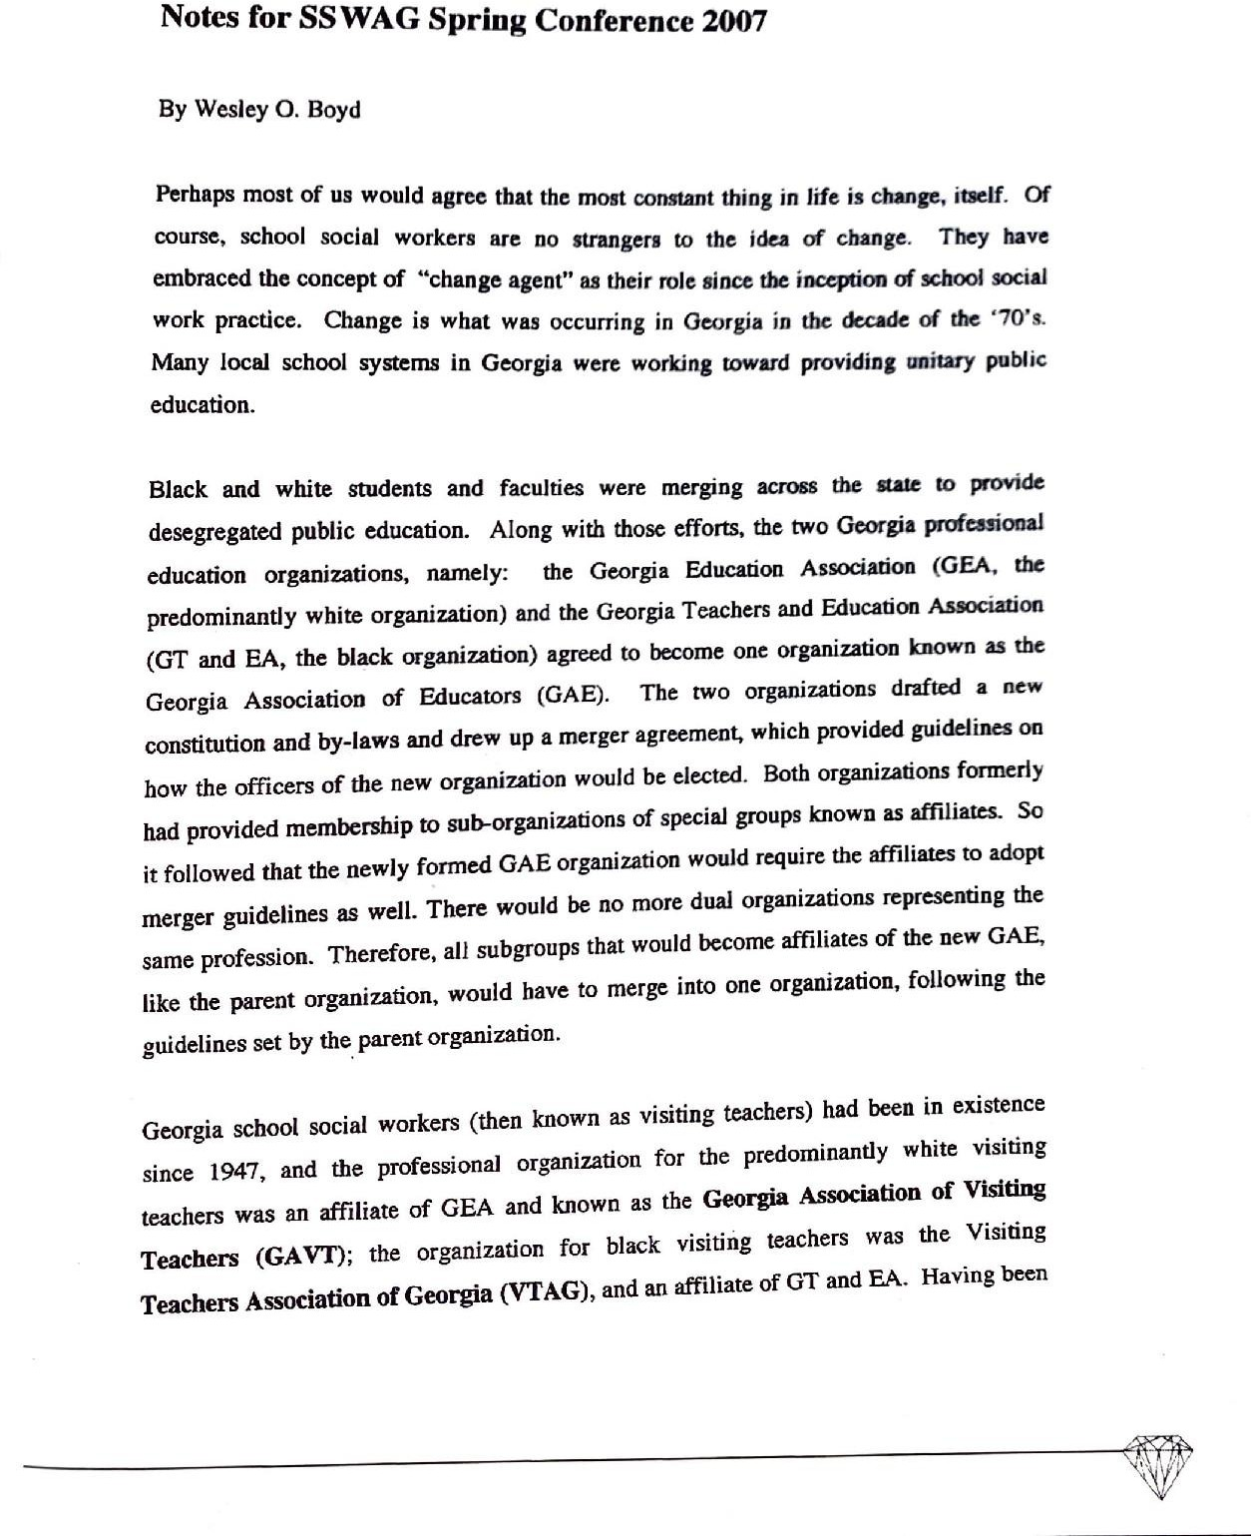

g;va ftp d)/zcdve fzom GAB, tho two visiting teacher organizations act abo
one professional organizatlon. In IP7i, the two organizations drifted a new tt q
and by-laWs along with a merger agrttcieni to become the
AssofiafiRg. or GVTA, The merger Agreement waa ratified and called for the alte y$ of the ace of the president for a priiod of 10 years. The first president of the mere organization, OVTA, was Wesley O. Boyd, the form pmaeni of VTAG end • ›isisn$ teacher in the Atlanta Public Schools.

The by-laws provided tbat from tbis point on tBc office of ‹/›• pméds‹x xo•/d b• nlkd
*7 *^ who had s•tv^d as the provioua yczr's prcaidzct-elf Oic vice president would be the immediate past president; and there would be, of course, a nee preaidontmleet. The mer8or wa8 a major change for Georgia visiting teachers. They were nov as officially intcgrated professional organizaäon. The term “officiaily” ig ttsed bofansc even helene
tfte ioerger, liza GAVT f›ad blaM momt›ee

Beyond tbe merger, itae)f, there were otber gigaifiicant aod izausual sitnatioaa tbat bear mention. One was that tbc merger, calling for tbe first president to f›c seie‹xed fzom VTAG, the bfack organiz:aâon, tensed the president-eleci frown white organization to
serve an additional year as a president-clef Thnre had been no other situation in the history of the GAVT that required the president-elect to serve two consecutive years bsfore assuming the office of president. Ellen Venable of Fooyth Gounty, however. graciously undertook the task. Site, of COurse, 6ecame president of GVTA in 1972.

Another unique situationoccurred in January of 1972, when the mosi esteemed Jack G. Thomas died. Jack was thc Cfio«linatorof Visiting Teacher Services for the Georgia “ Department of Education. He sucGUITibed to a heart attack and everyone was crushed
because Jack had beeR a moving >‹J* J@ . Had he lived, no doubt he would
be taking his rightful place amODQtb< G•orsia pi‘nxf O* *'° a'°°t P 'f••*'R =d organization. The Usitipg teaCher services j3ositioit. whlCh Jgflk had held, reaped vacant tlntil October of 1972. W•sl y Boyd then filled iI. Tbe uRiqomeSS O Situatioll was twO-fold: 1) WeSl , •» a• ij*n person of COl‘r '°I° " S'r*‘ “

O*d'gg * O 'S nS TCbCbei SefYiCe8 fOf ti2C Georgia DepafpTicfit Of EdUctäon; and
' " • ®' ° >* *° iä $ poifitntent, imiDediate past president of GBA OF Yite
Qtcsident as called for by thenew conadtinion and by-1aws.

It tbC timC Of the mergerin l97l, there••ie approximately 255 visiting teachers within tbc st•tc of Geo•si• Ortbat •urabcr, approxi„,a,Iy 40 (,as.) were black aad 2:s (84s) wb't°. ’^ !98o, a* r8<d orgazizatio« chu›g‹d ia ›zaz›x to scbool so«i ! Wo r
on of Georgia (SSWAG), and it has oontinued ita spiiaiing evoluties toward
a• ng täc 8°al id•n«a -itb the establiskment of die sowice in 1945 ——the
«fOn Of bal word services deaig»ed to ai8i& sclïOOl8, families, ant cmuDnnity in
providing the constitutiooally guarantecd educationaj opportuniäes to al) Georgia school children. I ani exceedingiy gratefui for baving made part of die jomiey with Georgia School Sotial Workers, and I sincerely wish for SSWAGa continued succo4sfu) trek iDtD

