School Social Workers Association of Georgia
Activity Calendar 2023-2024
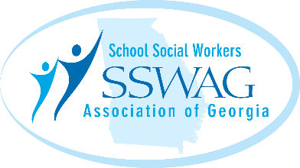

Date | Time | Activity | Location
May 16, 2023 | 9:00 am | Executive Board Meeting | Virtual
May 31-June 2 2023 | Various | Summer Retreat | TBA
August 1- September 29, 2023 | Send in entries | Video Contest | Send in entries
August 15, 2023 | 9:00 am | Executive Board Meeting | Virtual
October 10, 2023 | 9:00-10:30 | Daring Greatly Book Study | Virtual
October 2023 | 9:00-3:00 | Fall Virtual Conference | Virtual
November 2023 (Tentatively) | 10:00-3:00 | SSW Day at the Capitol | Atlanta, GA
November 14, 2023 | 9:00-11:00 | Executive Board Meeting | Virtual
December | All month long | SSW’s Give Back Challenge | All month long
January-April 2024 | Various | SSW’s LEAD Program | Virtual
February 20, 2024 | 9:00-11:00 | Executive Board Meeting | Virtual
March 3-8, 2024 National School Social Work Week

March 2024 (Tentatively) | 10:00-3:00 | SSW Day at the Capitol | Atlanta, GA
March 2024 | Various | Spring Conference | TBA
May 14, 2024 | 9:00-11:00 | Executive Board Meeting | Virtual
June | TBA new administration | Summer Retreat | TBA new administration

*No meetings scheduled the months of December and July

